Mpox Partner Toolkit

Contents
Why is this toolkit needed? 1
Mpox general information and FAQ 2
Flyer for general audiences 2
Related resources 3
Attachments
Sample social media posts and graphics
Sample script for your own videos or audio recordings
Health care provider communication guide
This can also be used by service providers

How to Use this Toolkit
The Washington State Department of Health (DOH) developed this toolkit to help partners communicate with people in Washington about mpox (previously known as monkeypox). It includes general information along with items for organizations that serve populations that may be at risk of contracting mpox and for service and health care providers. Use the following content as-is or customize it to address your audience’s needs.

Why is this toolkit needed?
Mpox infection can cause an illness that includes rashes and other symptoms. It does not commonly occur in the United States, but in 2022 there was a global outbreak of mpox that affected the United States and Washington. Mpox can spread person-to-person with any kind of close, skin-to-skin contact, regardless of sexual orientation, gender identity, or age, including children. Anyone can get mpox.
Many people want to know more about mpox. They especially may want to know if they’re at risk, and if they are, what they should do. This kit will help you give accurate information to your members, constituents, or followers and help them know what to do whether they’re at risk for mpox or not.

Vaccination
There is a vaccine to prevent mpox infection but it is not available to everyone. Help people know if the vaccine is recommended for them by sharing information from this toolkit or www.doh.wa.gov/mpox.
Answering Questions
Many questions about mpox can be answered at www.doh.wa.gov/mpox or with items in this toolkit, such as the flyers.

Mpox General Information and FAQ
Find general information and Frequently Asked Questions at www.doh.wa.gov/mpox. This website is maintained with up-to-date information about mpox. You may link to or use content from this page as needed. Credit Washington State Department of Health.
The site includes information about risk, symptoms, testing, treatment, vaccination, and more.
Information for health care providers can be found at this direct link: https://doh.wa.gov/you-and-your-family/illness-and-disease-z/mpox/frequently-asked-questions This page may also be helpful for people who aren’t providers but have questions about the disease or the vaccine.

Mpox Information Flyer
This flyer is available in 12 languages and is accessible on www.doh.wa.gov/mpox. Here are the direct links to each language.
- English
- Arabic
- Simplified Chinese
- Traditional Chinese
- Khmer (Cambodian)
- Korean
- Punjabi
- Russian
- Somali
- Spanish
- Tagalog
- Ukrainian
- Vietnamese

Related Resources
DOH Resources
- DOH mpox webpage (English)
- DOH mpox webpage (Spanish)
- Mpox FAQs and Resources for Health Care Providers
- Federally Qualified Health Center (PDF)
- Mpox Care Kit (PDF) | Spanish
- How to Take Care of Yourself When Diagnosed With Mpox (PDF) | Spanish
- Dealing With Rectal Mpox Symptoms (PDF) | Spanish
CDC Resources
- CDC mpox webpage
- Mpox and Safer Sex (PDF)
- Social Gatherings, Safer Sex and Mpox

Sample Social Media
Here are some sample social media posts you can copy and post to your own accounts, or modify the text and hashtags as needed. To use the graphics, download the toolkit, then you can right-click on the graphic below, click “save as picture.” You will then be able to include it with your post.

Topic | English sample post | Spanish sample post
Risk levels | Certain activities and situations can pose a higher or lower risk of getting mpox. Knowing the general level of risk can help us make informed decisions that protect us and our communities.  Get your questions answered at doh.wa.gov/mpox.  #mpox  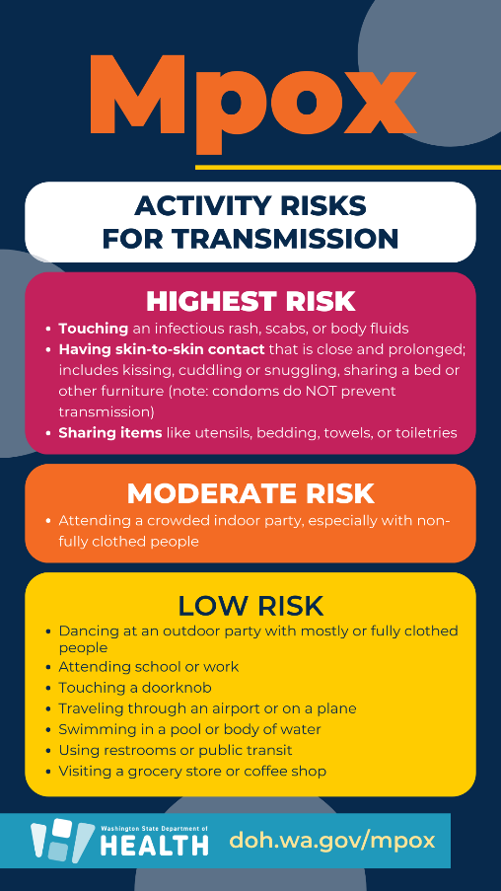 | Ciertas actividades y situaciones pueden presentar un riesgo mayor o menor de contraer el virus de la viruela símica (Mpox en Ingles). Conocer el nivel general de riesgo nos puede ayudar a tomar decisiones informadas que nos protejan a nosotros y a nuestras comunidades.  Obtenga respuestas a sus preguntas en https://doh.wa.gov/es/viruela-simica.  #viruelasímica #mpox  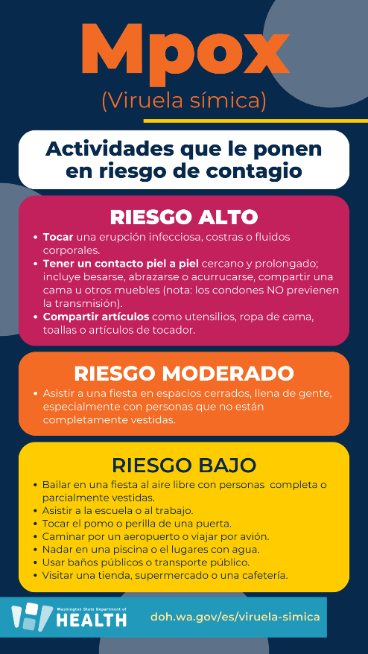
Low risk | Help protect others. Mpox does not spread easily unless there is close, direct contact with a person who has symptoms. If you have symptoms, like an unusual rash or blisters, cover it and see a health care provider as soon as possible.  Get your questions answered at doh.wa.gov/mpox.  #mpox  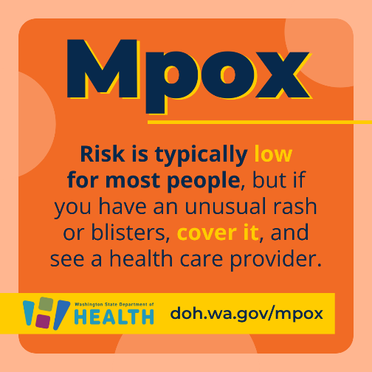 | Ayuda a proteger a los demás. La Mpox no se propaga fácilmente a menos que haya un contacto cercano y directo con una persona que tenga síntomas. Si tiene síntomas, como sarpullido o ampollas inusuales, cúbralo y consulte a un proveedor de atención médica lo antes posible.  Obtenga respuestas a sus preguntas en doh.wa.gov/es/viruela-símica.  #viruelasímica #mpox  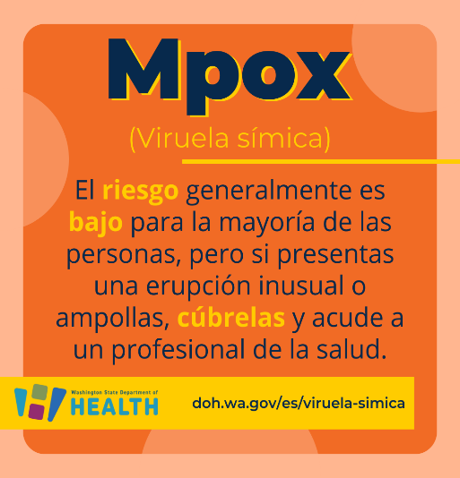

Mpox Educational Video or Audio Script
How to use this script template
This script content addresses several topics related to mpox, previously known as monkeypox. You can use this script to create videos, webinars, trainings, radio shows or podcasts, or any other situation where you are sharing information verbally.
This script is written for a brief and generally informative coverage of mpox and how it affects the communities disproportionately affected by mpox. Information for additional topics is listed and linked at the bottom of this document. Use those links if you want to go deeper into another topic and add more to your video. The links take you to the DOH mpox webpage. We update that page as we learn more about the outbreak, so you’ll always have the most up-to-date information.
If you create a video, we suggest keeping it under three minutes so people can easily watch and remember what they learned. You do not need to use all the content in one video. If you would like to use all of the content, consider creating several short videos instead of one long video. If you are doing something longer, like a podcast, you may be able to use more content at once.
The information in this script is accurate as of the date of publishing, but recommendations may change. Please confirm the information is correct before sharing.

Suggested Partner Script:
[Personalized opening (10-15 seconds): introduce yourself, what organization you represent, and your role within your organization or what community you are affiliated with and your role. Share why you are investing your time in putting together this video or other project.]
There is a lot of information out there about mpox, previously called monkeypox. It can be overwhelming trying to make sense of new information being shared. The information I will share today comes from the Washington State Department of Health.
Mpox is a disease caused by a virus. The infection can cause a rash, fever, headache, and other symptoms that may last for two to four weeks. The rash can look like pimples, blisters, or scabs. Most people recover in a few weeks, but the disease can be serious, especially for immunocompromised people, children, and pregnant people.
Anyone can get it, regardless of one’s sexual orientation or gender identity. Both adults and kids can get it.
Mpox can spread by skin-to-skin, mouth-to-mouth and mouth-to-skin contact. This includes sexual and non-sexual contact. Anyone who is or has a partner who is sexually active with multiple partners can be at an even higher risk for being exposed to mpox. It can also be spread through contact with virus-contaminated objects or infected animals. For example, it can be spread through hugging or sharing clothes with a person who is infected.
We encourage anyone who has an unusual rash and thinks they may have mpox to talk to a medical provider and find out if they should be tested even if they have been fully vaccinated.
Mpox vaccines are available. Anyone who is at an increased risk of infection or may have had close, skin-to-skin contact with someone who could have mpox in the last 21 days should talk to a health care provider and find out if they are eligible for vaccination. Vaccination can prevent or lessen the severity of mpox if given within four days of exposure.
For updated information on mpox, visit the Washington State Department of Health website at www.doh.wa.gov/mpox.

Use the linked information if you want to address:
- How mpox is spread
- Prevention of mpox
- What to do if you have been exposed to mpox
- How to get tested for mpox
- Where to get an mpox vaccine
- Symptoms of mpox
- What treatments (antivirals) are available for mpox
- Washington State Mpox Data
- 2022 Mpox Outbreak Information

Health Care Provider Communication Guide
on Mpox

Avoiding Stigma
Many individuals face several barriers when accessing and receiving medical care. Self prejudice, provider-related discrimination, social stigma, fear of disclosing sexual orientation or gender identity, or past bad experiences can lead to health disparities and general mistrust of the medical system. This includes individuals with minority sexual or attractional orientations, gender identities, gender expressions, and sex development (referred to here as lesbian, gay, bisexual, transgender, queer people, people born with intersex variations, and asexual people).
How we communicate about mpox (previously known as monkeypox) is critical in supporting people to take effective action to help combat the disease and to avoid fueling fear and stigma. As a health care provider, you can help create an environment in which the disease and its impact can be discussed and addressed openly, honestly, and effectively.
Words matter. When talking about mpox, certain words may have a negative meaning for some people and fuel stigmatizing attitudes. They can perpetuate negative stereotypes or assumptions, strengthen false associations between the disease and other factors, create widespread fear, or dehumanize those who have the disease.
The following best practices provide excellent ground in caring for people at risk of contracting mpox.

Terminology

Understand Concept Terms and Phrases
- As much as possible, use the term mpox to refer to the infection caused by the monkeypox virus (aka MPXV), not monkeypox, though you can clarify that name with your patients. This helps prevent association with specific animals or geography.
- When obtaining a patient’s history, ask about their risk factors by obtaining a sexual history, recent travel history, and if they have been around anyone with mpox, to better understand their health risks.
- When describing their sexual orientation or partners, some individuals may use terms such as fag, dyke, gay, homo or queer. While the patients might use these terms, they are considered derogatory when used by a health care provider to describe a patient. Listen to your patient and follow their lead. When in doubt, ask the patient how they should be described.
- Make a note in the records to use this description during future visits. Electronic medical records (EMR) may require modification to provide appropriate terminology.
- Ask the patient what pronouns they use if it is not in the medical record. Share your pronouns with your patient as well, even if you feel your pronouns are obvious. Use the patient’s correct pronouns and note them in your chart or EMR.
- Be culturally sensitive and use the name the patient wishes to be called.

How to Address Myths and Avoid Negative Language
In addition to avoiding spreading myths and misinformation yourself, help your patients avoid it as well. If a patient brings up misinformation, respectfully correct them and offer accurate information. For example, if they say, “I’m not at risk because I’m not gay,” you can let them know sexual practices are not the only risk factor and anyone can get mpox.
- Avoid labeling mpox as a disease that only affects gay/bi men, or only people with certain sexual practices. This is not true. Mpox can and does affect anyone, including children. It is spread by skin-to-skin contact, including non-sexual contact, and close face-to-face interaction.
- Do not call mpox a sexually transmitted infection or disease. It is not an STI or STD.
- Avoid unintentional blaming.
- Avoid dehumanizing language. Use first-person language.
- Do not refer to people with the disease as “mpox cases”.
- Do not repeat or share unconfirmed rumors and avoid using language designed to generate fear.

About Vaccine Eligibility
- Mpox vaccines are recommended for those who may have been recently exposed to the virus or have a high risk of mpox infection.
- Vaccine recommendations are made based on risks for exposure. The vaccines are not limited or recommended based on sexual orientation, sexual practices, or gender identity.

Communication Guidance
Stigmatizing, blaming, name calling, or shaming people because of a disease is never appropriate. Stigma can stop people from accessing health care services and make it harder to prevent transmission.
You can play a role in preventing discrimination by:
- Being empathetic
- Showing kindness
- Speaking up against negative stereotypes
- Staying calm
- Supporting your own and your patients’ mental health
- Openly communicating
- Emphasizing the effectiveness of protective measures to prevent the spread of mpox
Be clear in messaging that while some groups have been disproportionately affected in this outbreak, anyone can get it. It spreads many ways. (If your patient wants more detail, mention that past outbreaks have not affected the same groups as this one and it’s situational. It is not because of any certain sexual orientation or practices.)
Fear of judgment can stop people from seeking the health care and social support they need, so it’s critical to let people know your office does not judge them.
Do not share the names, identities, location, or other identifying information of people who have mpox or are in isolation.

More Information
- For the most current information on mpox, visit the Washington State Department of Health website at www.doh.wa.gov/mpox.
- Information For Healthcare Professionals | Mpox | Poxvirus | CDC

To request this document in another format, call 1-800-525-0127. Deaf or hard of hearing customers, please call 711 (Washington Relay) or email doh.information@doh.wa.gov.

