To the parents/guardians of:

AVERY 5160 LABEL HERE
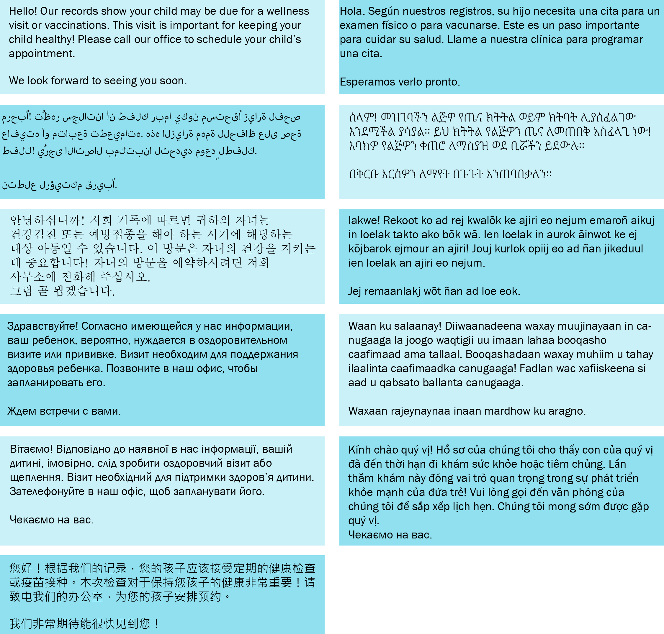
OLY CLINIC (111) 111-1111 | To request this document in another format, call 1-800-525-0127. Deaf or hard of hearing customers, please call 711 (Washington Relay) or email civil.rights@doh.wa.gov. May, 2023 DOH 348-964

