Transfer Records
All Vibrio parahaemolyticus products being transferred from a harvester to a dealer must have a transfer record or transportation document.
This document must have the following information (example below):
- The date of harvest.
- The time of harvest (time the first oyster was removed from the water or exposed to the air by the receding tide).
- The air temperature at the time of harvest.
- The water temperature at the depth of the oysters or an internal meat temperature of the product being harvested.
- The risk category for the harvest area.
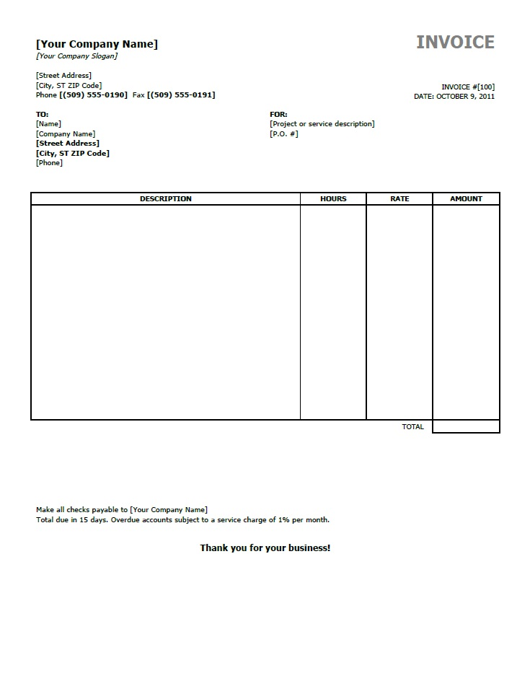
Harvest date: 7/11/15
Harvest Time: 6:00 am
Air Temp.: 60°
Water Temp.: 60°
Risk Category: 3
If product is cooled prior to transfer the harvester must include the following (example below):
- The date of harvest.
- The time of harvest (time the first oyster was removed from the water or exposed to the air by the receding tide).
- The air temperature at the time of harvest.
- The water temperature at the depth of the oysters or an internal meat temperature of the product being harvested.
- The risk category for the harvest area.
- The temperature the product was cooled to.
- The time the temperature was taken.
Harvest date: 7/11/15
Harvest Time: 6:00 am
Air Temp.: 60°
Meat Temp.: 60°
Risk Category: 3
Cooled to: 48°
Time: 7:00 am

