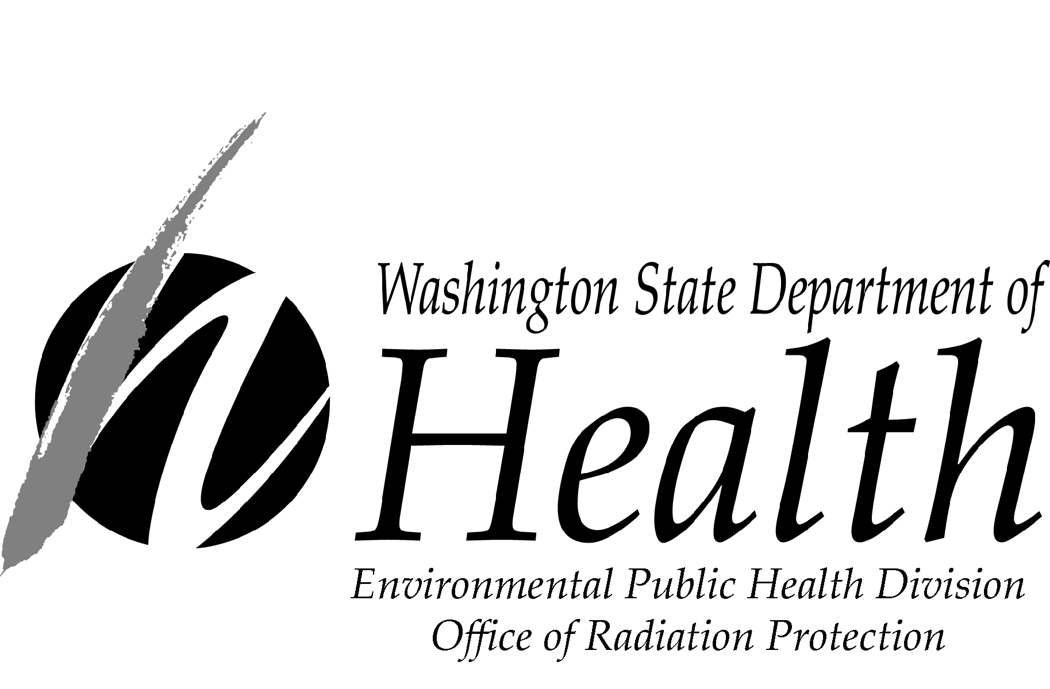License / ALARACT Revision Request
ALARACT: As Low As Reasonably Achievable Control Technology

Any increase to abated or unabated potential to emit (PTE) is considered a ‘modification’ and requires an Appendix A Application per Washington Administrative Code (WAC) 246-247.
DOH 320-105 March 2015

Submittal Date:

 | License Revision |  |  | ALARACT Revision
 | Condition Number: |  |  | New ALARACT Revision #:
 | Report of Closure

PROJECT IDENTIFICATION

Project Title:
Current Notice of Construction (NOC) Number(s):
Emission Unit (EU) Number(s):
Current Approval Letter Number(s):

DESCRIPTION OF CHANGE

You may attach additional pages, as needed. We will provide a new approval letter containing any new or modified conditions that result from the following proposed change.

Number of Attachments:

Enter original and proposed wording here:

LICENSEE APPROVAL

This form must be approved and submitted by senior management. The Radiation Safety Officer (RSO) may submit only if senior management has filed a statement with the Washington State Department of Health authorizing the RSO to approve applications and radiation safety program commitments.

Approving Manager / RSO
Name:
Title:
Date Approved:
Signature (if submitting hard copy):

Send completed form to:
Washington State Department of Health, Radioactive Air Emissions Section
309 Bradley Boulevard, Suite 201, Richland, Washington 99354
Fax: (509) 946-0876 or Email: airrichland@doh.wa.gov

