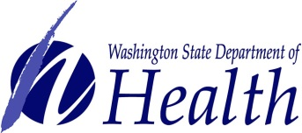 | Washington Recovery and Monitoring Program  Post Office Box 47852, Olympia, WA 98504–7852  Telephone: 360-236-2880 Fax: 360-236-4704  Email: wramp@doh.wa.gov
Request for Speaking Engagement

A lack of knowledge about substance use disorders is a major risk factor for healthcare practitioners. Washington Recovery and Monitoring Program (WRAMP) staff are available to provide no cost education and consultation to your staff and students about substance use disorders among healthcare professionals and the WRAMP program.
Please complete the following and return to WRAMP if you would like to schedule a presentation or training.
Name of Organization:
Address:
City: |  |  |  |  |  |  |  |  |  | State: |  |  | Zip:
Contact Person:
Telephone: |  |  |  |  |  |  |  |  | Email
Requested Date(s):
Presentation/Training Topic(s):
Available Audio/Visual Equipment:

Please mail, email, or fax this form.

