Public Notification Form
Notice to Water System Users: Coliform Monitoring Violation
331-163-F • Revised 3/25/2022

Water System: ID # County:
is required to monitor your drinking water for specific contaminants on a regular basis. Results of regular monitoring indicate whether your drinking water meets health standards. During the month of we either did not monitor or test for coliform bacteria or collected fewer samples than we were required to collect. Therefore, we cannot be sure of the quality of your drinking water during that time.

At this time:
No action is required by the users.

We collected the routine coliform sample required for the month of and the lab found no coliform bacteria.

We will collect samples in the future as required.

Other information for customers:

For more information, contact at ( ) - or at .
(owner or operator) (phone number) (address)

Please share this information with all the other people who drink this water, especially those who may not have received this notice directly (for example, people in apartments, nursing homes, schools, and businesses.) You can do this by posting this notice in a public place or distributing copies by hand or mail.

This notice is sent to you by Water System on

Coliform Monitoring Public Notice Certification Form
By completing the information below, we certify to the state Department of Health that we distributed public notice to our customers.
Please check the appropriate box and fill in the date you distributed the notice:

Notice was mailed to all water customers on
Notice was hand delivered to all water customers on .
Notice was posted with Department of Health approval at:
____________________________________ on
Sign below and send this completed notification and certification form to us at the address checked below.

Signature of owner or operator Position Date

Northwest Region  Department of Health  20425 72nd Ave S, Suite 310  Kent, WA 98032-2388  brandon.katz@doh.wa.gov  Fax: 253-395-6760 | Southwest Region  Department of Health  PO Box 47823  Olympia, WA 98504-7823  SWRO.Coli@doh.wa.gov  Fax: 360-236-3029 | Eastern Region  Department of Health  16201 E Indiana Ave, Suite 1500  Spokane Valley, WA 99216  joseph.perkins@doh.wa.gov  Fax: 509-329-2104

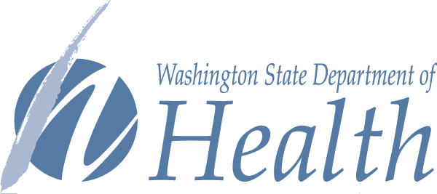
To request this document in another format, call 1-800-525-0127. Deaf or hard of hearing customers, please call 711 (Washington Relay) or email civil.rights@doh.wa.gov.

