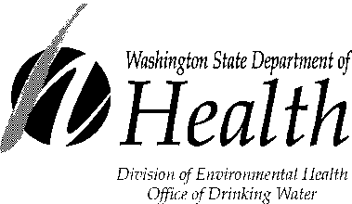
Translated Drinking

Water Warnings
DOH 331-246
July 2004

English | This report contains important information about your drinking water.  Have someone translate it for you,  or speak with someone who understands it. | Boil your water before using. | Don't drink the water. | Children under 12 months old should not drink the water.  Don’t use the water to make formula.
Amharic | 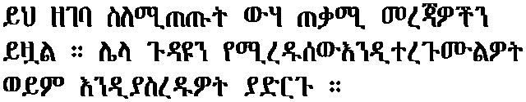 | 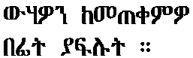 |  | 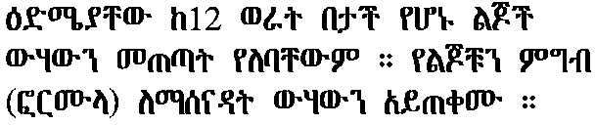
Arabic | 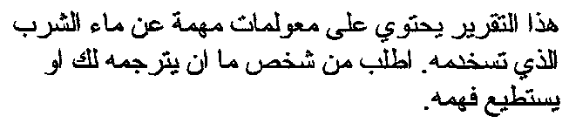 |  | 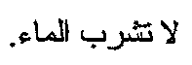 | 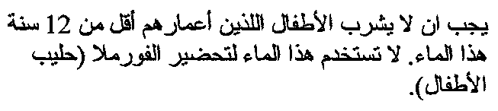
Cambodian  (Khmer) | 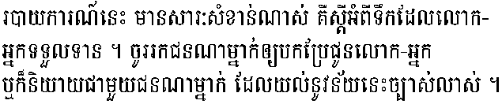 | 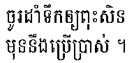 | 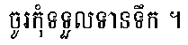 | 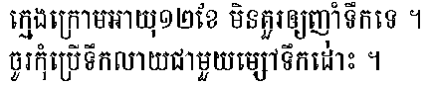
Chinese Simplified | 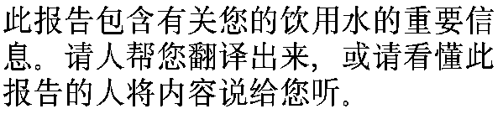 | 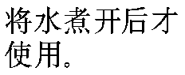 | 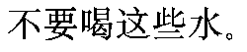 | 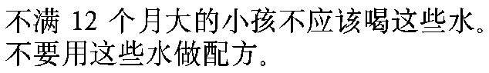
Chinese Traditional | 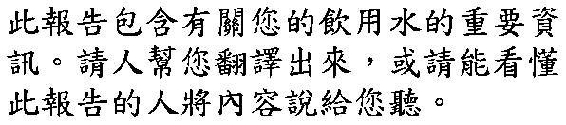 | 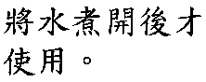 | 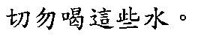 | 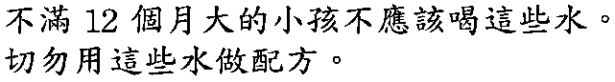
Farsi | 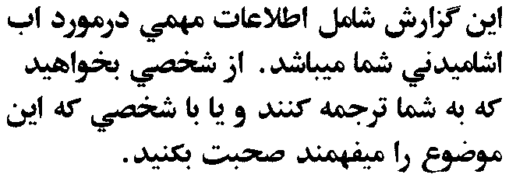 | 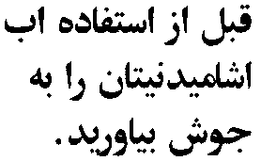 |  | 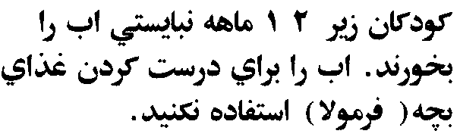
French | Ce rapport contient des informations importantes à propos de votre eau potable. Demander à quelqu’un de traduire ces informations pour vous ou discuter avec une personne qui comprend ces informations. | Faire bouillir l’eau avant de l’utiliser. | Ne pas boire l’eau. | Les enfants des moins de 12 mois ne doivent pas boire l’eau. Ne pas utiliser l’eau dans une préparation lactée pour nourrisson.
Greek | 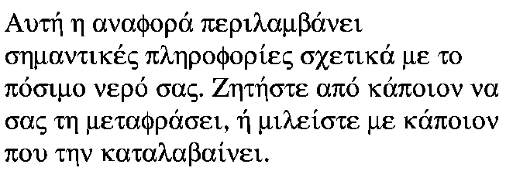 | 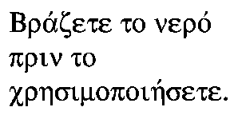 | 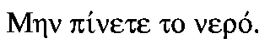 | 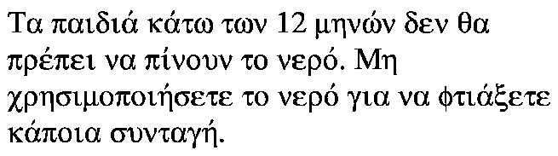
Hebrew | 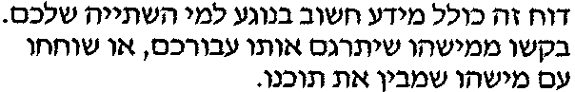 | 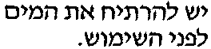 |  | 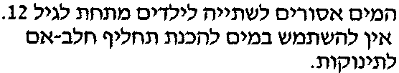
Hindi | 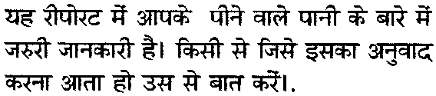 | 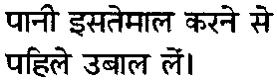 | 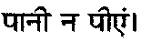 | 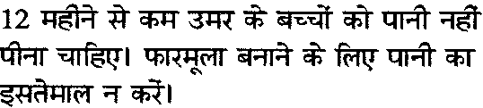
Hmong | Dlaim ntawv tshaabxu nuav muaj lug tseemceeb heev nyob rua huv kws has txug cov dlej mej haus. Kuas ib tug paab txhais rua koj, los nrug ib tug kws paub lug thaam. | Uantej kws yuav siv mej cov dlej nuav yuav tau muab nwg rhaub kuas npau. | Tsi txhob haus cov dlej nuav. | Cov mivnyuas kws tsi tau muaj 12 xyoo tsi txhob haus cov dlej nuav. Txhob muab cov dlej nuav moog tov mig.
Japanese | 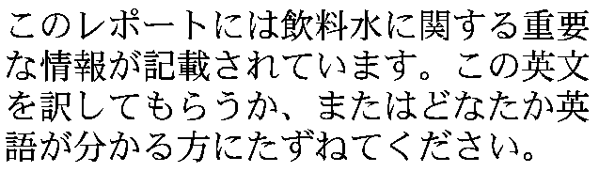 | 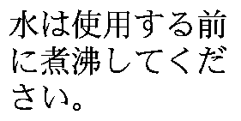 | 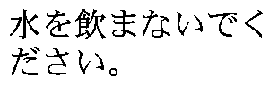 | 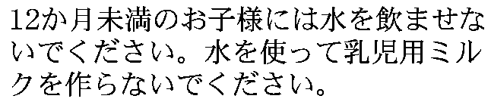
Korean | 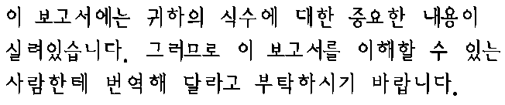 | 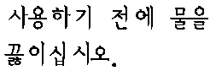 | 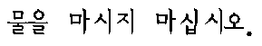 | 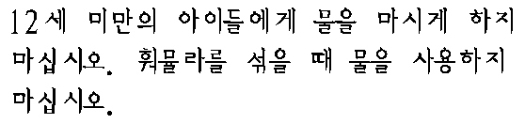
Laotian | 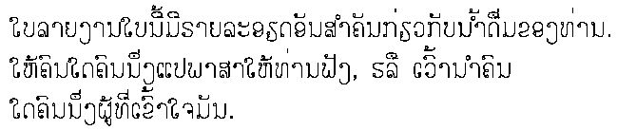 | 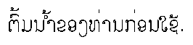 | 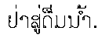 | 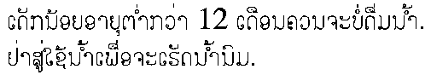
Oromo | Gabaasii kun odeeffanno barbachisa wa’ee bisaan dhugaatii qaba. Akkaa isinii turjumaa’uu gaafadhaa yokaan nama afaan keessan dubbatuu dubbisaa. | Bisaan oso hindhuggneen duraa akka danffisttan. | Bisaan kan hindhuginaa. | Daa’imman baatii(ji’aa) 12 hingahiin bisaan kan dhuguun isaan irra hinjiru. Bisaan kana foormmulaa(Nyaata Ijoolee) qopheessuf itii hinfayyadamina.
Polish | Następujący raport zawiera ważną informację na temat wody pitnej. Proszę poprosić kogoś o przetłumaczenie lub porozmawiać z kimś kto rozumie. | Należy przegotować wodę przed spożyciem. | Proszę nie pić wody. | Dzieci w wieku poniżej 12 miesięcy nie powinny pić tej wody. Proszę nie używać tej wody do przygotowywania formuły.
Punjabi | 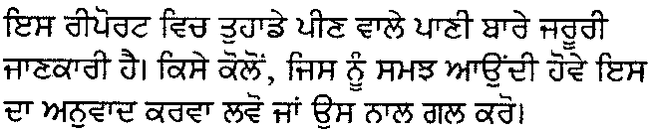 | 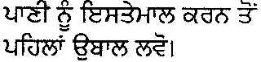 | 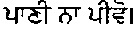 | 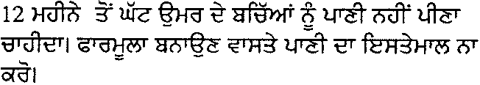
Russian | 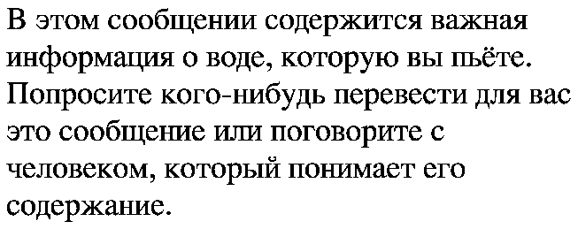 | 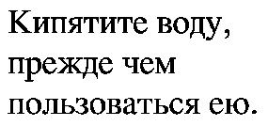 | 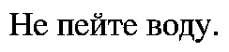 | 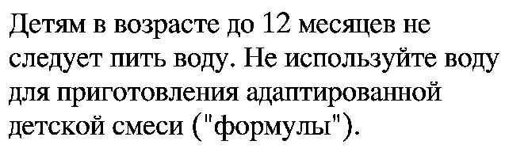
Samoan | O le lipoti lenei o lo’o iai ni mea e sili ona taua e uiga i le vai o lo’o e taumafaina nei. Su’e se tagata e fa’aliliuina mo oe, po’o lou talatalanoa i seisi e iai sona malamalamaga i lenei mataupu. | Tunu le vai ia pupuna ona fa’atoa inu lea. | Aua le inuina le vai. | Tamaiti uma lava e i lalo o le 12 tausaga e le tatau ona inuina le vai. Aua le fa’aaogaina le vai e sui ai ni vaila’au po’o le palu ai o ni mea tausama.
Serbo-Croatian | Ovaj izvještaj sadrži važnu informaciju u vašoj vodi za piće. Neka vam neko prevede, ili popričajte sa nekim ko se u ovo razumije. | Proključajte vodu prije upotrebe. | Ne pijte vodu. | Djeca ispod 12 mjeseci starosti ne bi trebala piti vodu. Ne koristite vodu za pripravljanje hrane u flašici za bebe.
Somali | Warbixintan waxay wadataa macluumaad muhiim ah ee la xiriira biyaha aad cabtid. Cid ha kuu tarjunto ama la hadl cid fahmaysa. | Karkari biyaha inta aadan isticmaalin. | Ha cabin biyaha. | Carruurta sannad jir ka yar ma aha inay biyaha cabaan. Ha u isticmaalin biyaha inaad kula qastid caanaha ama raashinka la qaso ee carruurta.
Spanish | Este informe contiene información importante acerca de su agua potable. Haga que alguien lo traduzca para usted, o hable con alguien que lo entienda. | Haga hervir el agua antes de usarla. | No beba el agua. | Los niños menores de 12 meses de edad no deben beber el agua. No use el agua para preparar la fórmula para bebés (biberón).
Tagalog | Naglalaman ang report na ito ng importanteng impormasyon tungkol sa iyong iniinom na tubig. Magkaroon ng isang tao na isasalin ito sa iyong wika para sa iyo, o makipag-usap sa isang tao na nakakaintindi dito. | Pakuluin ang inyong tubig bago gagamitin. | Huwag inumin ang tubig. | Ang mga bata na kulang sa 12 na buwan ang gulang ay hindi dapat na iinumin ang tubig. Huwag gagamitin ang tubig sa paggawa ng pormula.
Thai | 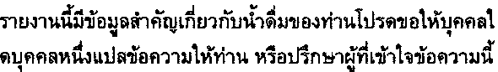 | 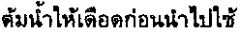 | 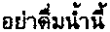 | 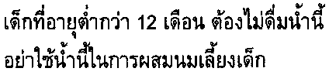
Tigrigna | 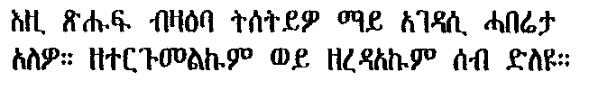 | 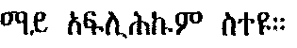 | 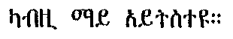 | 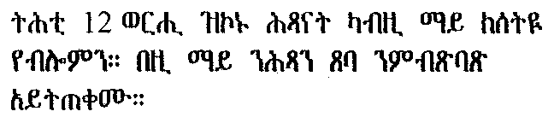
Ukrainian | 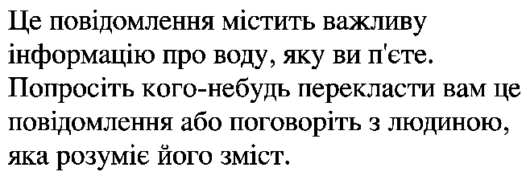 | 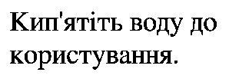 | 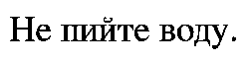 | 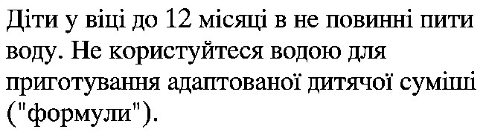
Vietnamese | 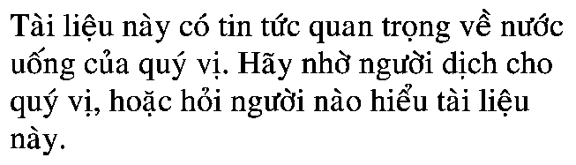 | 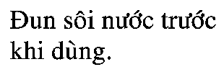 | 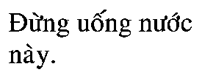 | 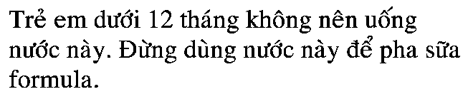
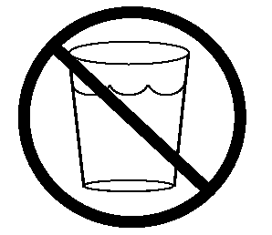
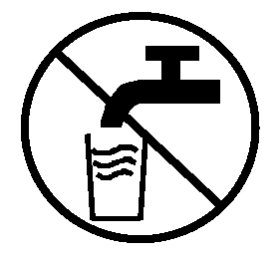
The water glass and faucet may be useful in a posted notice
that would be seen by many non-English speaking people
to illustrate that they should not drink the water.

