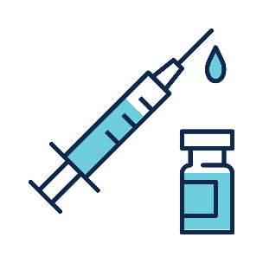

DOH 402-203 May 2023

To request this document in another format, call 1-800-525-0127. Deaf or hard or hearing customers, please call 711 (Washington Relay) or email [doh.information@doh.wa.gov](mailto:doh.information@doh.wa.gov)

Please **do not** visit if you have a fever or cough

* **Get a flu vaccine**
* **Wash or sanitize your hands upon arrival and before leaving**
* **Use a tissue or your sleeve when you cough or sneeze**
* **Wash or sanitize your hands after coughing or sneezing**
* **If you are sick and must visit, please ask for a mask**

**Modified from Public Health Seattle and King County materials**

**Help Protect   
Our Residents**