Washington Syndemic Planning Group Charter Amendment: Resolution #1

Resolution # 1

Washington Syndemic Planning Group (WSPG)
Charter and Bylaws - December 2022

Subject of Resolution:

To resolve that the following amendment be made to the Washington Syndemic Planning Group (WSPG) Charter and Bylaws- December 2022. The WSPG approves the following request for an amendment to its charter:

To add language to the Washington Syndemic Planning Group Charter of a dedicated planning year spanning July 1, 2022 to June 30, 2023 affecting the establishment of the goal requirements, committee activities, and schedules to support syndemic efforts of the Washington State Department of Health.

Articles and pages affected:
Article IV, Section 1. Positions (p.12)
Post planning year, effective July 1, 2022 to June 30, 2023, there will be three (3) Tri-Chairs of the WSPG: a Governmental Chair, a Provider Chair, and a Community Chair. The Provider Chair and the Community Chair serve in that capacity for one (1) year.

Article IV, Section 3. Appointments, Nominations and Elections (p.12)
Post planning year, effective July 1, 2022 to June 30, 2023, the full WSPG will annually elect one member to serve as the Community Co-Chair and one member to serve as the Provider Co-Chair for one (1) year.

Article VI, Section 3. Terms (p.16)
Post planning year, effective July 1, 2022 to June 30 2023, the Steering Committee members will serve for one (1) year with no options for extension.

Motion made by: JJ Baker

Seconded by: Ann Mumford
WSPG resolution to amendment request: Tally of Votes (yes, no, abstain, absent)

MEMBER | NAME | VOTE | MEMBER | NAME | VOTE
1 | Amy Hernandez | Absent | 12 | Lara West | Absent
2 | Ann Mumford | Yes | 13 | Lisa Al-Hakim | Absent
3 | Brigette Young | Yes | 14 | Monte Levine | Yes
4 | Christina Jackson | Yes | 15 | Omero Perez | Yes
5 | Christopher Archiopoli | Yes | 16 | Stephen Zeller | Absent
6 | Gina King | Absent | 17 | Walter McKenzie | Yes
7 | Howard Russell | Yes | 18 | William Harrison | Abstain
8 | James Sammuels | Absent | 19 | Yob Benami | Yes
9 | James Tillett | Yes | 20 |  | Yes
10 | JJ Baker* | Abstain | 21 |  | Choose an item.
11 | Jsani Henry | Yes | 22 |  | Choose an item.

I, the WSPG facilitator certify that the above resolution was passed by a majority of a quorum of this planning group, as indicated above.

Signature: Genee M Grimmett

Date of WSPG Meeting: September 26, 2023

Tri-chair signatures and date signed:

Monte Levine: 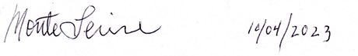

JJ Baker: 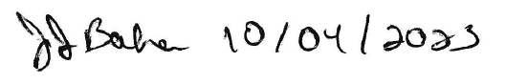

Elizabeth Crutsinger Perry: 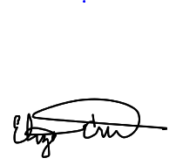10/10/2023

*JJ Baker is No Longer a Voting member of the WSPG

