DOH 342-034 Feb 2023

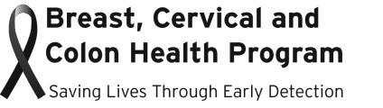

INCOME ELIGIBILITY TABLES
Effective January 12, 2024 – January 31, 2025

These tables determine income eligibility for the Breast, Cervical and Colon Health Program based on Federal Poverty Level (FPL):

Gross Yearly Income
Family Size | 250% FPL | 300% FPL
1 | $37,650 | $45,180
2 | $51,100 | $61,320
3 | $64,550 | $77,460
4 | $78,000 | $93,600
5 | $91,450 | $109,740
6 | $104,900 | $125,880
7 | $118,350 | $142,020
8 | $131,800 | $158,160
8+  Add per each additional member | $13,450 | $16,140

Gross Monthly Income
Family Size | 250% FPL | 300% FPL
1 | $3,138 | $3,765
2 | $4,258 | $5,110
3 | $5,379 | $6,455
4 | $6,500 | $7,800
5 | $7,621 | $9,145
6 | $8,742 | $10,490
7 | $9,863 | $11,835
8 | $10,983 | $13,180
8+  Add per each additional member | $1,233 | $1,345

