PART 2: DESIGN STANDARDS & CONSTRUCTION (MAHC 4.0)
Subpart A: Plan Submittal and Construction Permits
WAC 246-261-401000 Construction Permits
(1) Construction Permit. Prior to construction or ALTERATION of an AQUATIC FACILITY, the owner shall obtain a construction permit issued by the DEPARTMENT or LOCAL HEALTH OFFICER. Construction permits are valid for 18 months. The DEPARTMENT or LOCAL HEALTH OFFICER may extend the life of the construction permit by up to 12 months if requested by the owner or the owner’s representative. Once a construction permit expires, the owner is responsible for resubmitting an application for a construction permit.
(2) Approved Plans. In order to obtain a construction permit, the owner shall submit a complete plan to the department or local health officer for review and approval.
(3) Permit Issuance. No permit may be issued without approved plans. Permits shall be issued within 30 days of plan approval.
(4) Permit Denial. The construction permit may be withheld, suspended, revoked, or denied by the DEPARTMENT or LOCAL HEALTH OFFICER for noncompliance with the requirements of this chapter, and the owner will be provided:
(a) Specific reasons for the action taken and procedure for resubmittal;
(b) Notice of the rights to appeal and procedures for requesting an appeal; and
(c) Reviewer’s name, signature, and date of review and the action taken.

WAC 246-261-401010 Plan Submittal (2023 MAHC 4.1.1)
(1) Plans. AQUATIC FACILITY plans shall include all necessary construction documents to provide sufficient clarity to indicate the location, nature, and extent of the work proposed. Necessary construction documents include, but are not limited to, the documents listed in Subpart B, Content of Plans, and any additional information the department or Local Health Officer may request to determine compliance with this chapter.
(2) Conform. AQUATIC FACILITY plans shall show in detail that the AQUATIC FACILITY will conform to the provisions of this chapter as determined by the department or local health officer and to protect the health and SAFETY of the facility’s BATHERS and PATRONS. Plans shall also conform to all other applicable local, state, territorial, federal, and tribal laws.
(3) Plan Preparation. All plans shall be prepared, stamped, and signed by a DESIGN PROFESSIONAL proficient in the application of this chapter and all applicable local, state, territorial, federal, and tribal laws relevant to the project and who shall apply this chapter and all applicable laws when preparing project plans.
(4) Minor Alterations. Minor ALTERATIONS that do not have the potential to affect system hydraulics, air quality, structural integrity, or PATRON safety and health may apply to the DEPARTMENT or LOCAL HEALTH OFFICER for variance from requirements for plan preparation by a DESIGN PROFESSIONAL. The DEPARTMENT or LOCAL HEALTH JURISDICTION shall have sole discretion to approve or deny an application for variance.
(5) Required Statements. All plans shall include the following statements:
(a) “The proposed AQUATIC FACILITY and all equipment shall be constructed and installed in conformity with the approved plans and specifications,” and
(b) “No ALTERATIONS, changes, additions, or equipment not specified in the approved plans can be made or added until the plans for such ALTERATIONS, changes, additions, or equipment are submitted to and approved by the DEPARTMENT or LOCAL HEALTH OFFICER.”
Subpart B: Content of Plans
WAC 246-261-401021 Application and Site Information (2023 MAHC 4.1.2/4.1.2.1) AQUATIC FACILITY plans shall include:
(1) Names / Addresses. The name, address, and contact information for the owner, DESIGN PROFESSIONAL, and builder if available at the time of submission;
(2) Site Information. Relevant site information as dictated by the project scope of work. Site information may include the location of all utilities, wells, topography, natural water features, and potential sources of surface drainage;
(3) Plot Plan. Site plot plan including:
(a) A general map and detailed scaled drawings of the AQUATIC FACILITY site plan or floor plan with detailed locations of the AQUATIC VENUES, AQUATIC FEATURES, and HYGIENE FACILITIES; and
(b) The locations of all water supply facilities, sources of drinking water, public or private sewers, and
relative elevations of paved or other walkways and the EQUIPMENT ROOM floor shall be shown on the
plans with the elevations of storm and sanitary sewer inverts and street grade.
WAC 246-261-401022 Plans Details (2023 MAHC 4.1.2.2)
(1) Drawings. Detailed scaled and dimensional drawings for each individual AQUATIC VENUE shall include an AQUATIC VENUE area plan and layout plan along with dimensioned longitudinal and transverse cross sections of the AQUATIC VENUE.
(2) Operating Conditions. The plan shall include a proposal of anticipated operating conditions (water temperature(s), space temperature, space relative humidity, space dew point) and intended use for each type of VENUE (FLAT WATER, AGITATED WATER, HOT WATER) accepted by both the DESIGN PROFESSIONAL and owner/operator.
(3) Aquatic Venue Attributes. Detailed scaled and dimensional drawings for each individual AQUATIC VENUE shall include location and type of:
(a) INLETS;
(b) Overflows;
(c) Drains, including one or more cross-sections through the main drain;
(d) Suction outlets;
(e) Overflow gutters or devices;
(f) Piping;
(g) POOL design waterline;
(h) AQUATIC VENUE basins including bottom and sidewalls;
(i) AQUATIC FEATURES;
(j) Lighting;
(k) POOL markings; and
(l) Surface materials.
(3) Area Design. Detailed scaled and dimensional drawings of the AQUATIC FACILITY and for each individual AQUATIC VENUE, as appropriate, shall include location and type of:
(a) Design of AQUATIC VENUE ENCLOSURE including walls, fencing, entry and exit doors and gates, self-closing and latching hardware, and locks;
(b) Detailed view of the EQUIPMENT ROOM layout;
(c) Design of DECK, including paving materials, DECK slope, and DECK drains;
(d) Paved walkways and other hardscape features;
(e) SLIP-RESISTANT flooring;
(f) AQUATIC VENUE area finishes;
(g) Drinking fountains or other sources of drinking water;
(h) Entries and exits;
(i) Hose bibs;
(j) Fences;
(k) Telephones; and
(l) Area lighting, including photometric plans.
(4) Aquatic Venue Recirculation and Treatment Design. Detailed scaled and dimensional drawings for each individual AQUATIC VENUE shall contain a flow diagram showing the location, plan, elevation, and schematics of:
(a) Filters;
(b) Pumps;
(c) Chemical feeders and interlocks;
(d) Chemical controllers and interlocks;
(e) SECONDARY TREATMENT;
(f) Supplemental DISINFECTION systems;
(g) Ventilation devices or AIR HANDLING SYSTEMS;
(h) Heaters;
(i) Surge tanks, including operating levels;
(j) BACKFLOW prevention assemblies and air gaps;
(k) Valves;
(l) Piping;
(m) Flow meters;
(n) Gauges;
(o) Thermometers;
(p) Test cocks;
(q) Sight glasses; and
(r) Drainage system for the disposal of AQUATIC VENUE water and filter wastewater.
(5) Equipment Room Design. Detailed scaled and dimensional drawings for each individual AQUATIC VENUE shall contain a schematic layout of the AQUATIC VENUE EQUIPMENT ROOM showing accessibility for installation and maintenance.
(6) Chemical Storage Space Design. Detailed scaled and dimensional drawings for each individual AQUATIC VENUE shall contain a schematic layout of the AQUATIC FACILITY CHEMICAL STORAGE SPACE(S).
(7) Hygiene Facility Design. Detailed scaled and dimensional drawings for each AQUATIC FACILITY shall show the location and number of all available HYGIENE FACILITIES provided including dressing rooms, lockers, SHOWERS, lavatory, toilet FIXTURES, and DIAPER-CHANGING STATIONS.
WAC 246-261-401023 Technical Specifications (2023 MAHC 4.1.2.3)
(1) Accompanying Drawings. Technical specifications for the construction of each AQUATIC VENUE and all appurtenances shall accompany the drawings for the AQUATIC FACILITY plans.
(2) Technical Details.
(a) Technical Specifications. The following technical specifications shall be provided for each AQUATIC FACILITY:
(i) Water temperatures for each AQUATIC VENUE;
(ii) Effective surface area of each AQUATIC VENUE;
(iii) Space design:
(A) Listing of each room size (length, width, height).
(iv) Design/desired dry bulb and dew point temperatures;
(v) Design/desired relative humidity;
(vi) Type of water treatment; and
(vii) PERIMETER DECK and POOL DECK, which are the same as the WET DECK area defined in the ASHRAE 62.1.2019 Standard, which defines this area as the “area surrounding the POOL surface that is capable of being wetted during use or when POOL is occupied.”

(b) Details Not Shown on Plans. Each AQUATIC VENUE shall include all construction details not shown on the plans that relate to the AQUATIC FACILITY:
(c) Intended Use. During the design of the ventilation and CLIMATE CONTROL SYSTEMS for INDOOR AQUATIC FACILITIES, the DESIGN PROFESSIONALS shall consult with and obtain input from the owner/operator to address intended uses, type of AQUATIC VENUES and intended typical operating water temperatures, space air temperature, and relative humidity.
(d) Design Criteria Document. A design criteria document shall be written as a result of these consultations, signed by all parties involved and become a permanent document of the project specifications and owner’s manual.
(3) Water Sources. The technical specifications for each AQUATIC FACILITY shall include the sources of all water supplies.
(4) Area and Volume. Technical specifications shall include the water surface area and volume of each AQUATIC VENUE and associated water features, if applicable.
(5) Theoretical Peak Occupancy. The technical specifications for each AQUATIC FACILITY and each AQUATIC VENUE shall include THEORETICAL PEAK OCCUPANCY, respectively.
(a) Used for Designing Systems. The THEORETICAL PEAK OCCUPANCY for ventilation air for an AQUATIC VENUE shall be used for designing systems that serve BATHERS and PATRONS.
(b) Incorporate Non-Water Related Areas. The THEORETICAL PEAK OCCUPANCY for an AQUATIC FACILITY shall be used for designing systems that serve BATHERS and PATRONS and shall incorporate non-water related areas such as DECKS and other adjacent portions of the AQUATIC FACILITY not associated with the AQUATIC VENUE.
(c) Calculating Theoretical Peak Occupancy. The THEORETICAL PEAK OCCUPANCY shall be calculated by dividing the surface area in square feet of the AQUATIC VENUE by the density factor (D) that fits the specific AQUATIC VENUE being considered.
THEORETICAL PEAK OCCUPANCY = AQUATIC VENUE Surface Area / D +
(i) The density factors (D) are Water/BATHER-related:
(A) Deep water density factor = 30 ft² (2.79 m²) per BATHER.
(B) Shallow water density factor = 25 ft² (1.9 m²) per BATHER.
(C) SPA density factor = 10 ft² (0.9 m²) per BATHER.
(F) SURF POOL density factor = manufacturer-established capacity at any given time or 1000 ft²per bather for constructed SURF POOLS.
(ii) Non-water/PATRON-related:
(A) DECK density factor = 15 ft² (4.6 m²) per BATHER and 15 ft² per PATRON. Only PATRON deck occupancy will be used in calculating theoretical PEAK OCCUPANY.
(B) STADIUM SEATING density factor = 6.6 ft² (0.6 m²) per BATHER or PATRON.
(e) Aquatic Facility Theoretical Peak Occupancy. The THEORETICAL PEAK OCCUPANCY for an AQUATIC FACILITY shall be determined by adding the calculations for each AQUATIC VENUE together with PATRON-related occupancies in the AQUATIC FACILITY. Theoretical peak occupancy for each AQUATIC VENUE must be adjusted if the AQUATIC VENUE’S surge capacity is less than the amount of water displaced by the calculated Peak occupancy or bather load.
(6) Equipment Characteristics and Rating. The technical specifications and supplemental engineering data for each AQUATIC FACILITY and each AQUATIC VENUE shall include:
(a) Detailed information on the type, size, operating characteristics, and rating of all mechanical and electrical equipment;
(b) Hydraulic computations for head loss in all piping and recirculation equipment;
(c) Pump curves that demonstrate that the selected recirculation pump(s) are adequate for the calculated required flows; and
(d) For INDOOR AQUATIC FACILITIES, documentation that demonstrates that the INDOOR AQUATIC FACILITY is designed to meet the acoustic design criteria contained in WAC 246-261-4060XX.
(e) Documentation per WAC 246-161-40703X to demonstrate that the selected disinfectant feeders/equipment are of sufficient size and capacity, including evaluation of the CHLORINE demand factors in WAC 246-261-40703X.
(7) Recirculation Rate and Turnover. The technical specifications for each AQUATIC VENUE shall include the recirculation rate and TURNOVER TIME.
(8) Filter Media. The technical specifications for each AQUATIC VENUE shall include information on the filter media such as diatomaceous earth, sand, gravel, or other approved material.
(9) Equipment Specifications. The technical specifications for each INDOOR AQUATIC FACILITY shall include information on each piece of equipment associated with that INDOOR AQUATIC FACILITY. For climate control equipment, the specifications shall include the following items at a minimum: sensible cooling capacity, sensible heating capacity, MOISTURE REMOVAL CAPACITY (MRC) in lbs/hr, MOISTURE REMOVAL EFFICIENCY (MRE) as listed in the AHRI Standard 920-2020 Performance Rating of Direct Expansion-Dedicated Outdoor Air System Units or AHRI Standard 910-2014 Performance Rating of Indoor Pool Dehumidifiers, CFM of outside air, CFM of exhaust air, CFM of supply air, voltage, power requirements, and design temperature and humidity.
(10) Safety Equipment Specifications. The technical specifications for each AQUATIC FACILITY shall include information on all aquatic safety equipment.
(11) Design for Risk Management. The layout for zones of PATRON surveillance as specified in WAC 246-261-60303X shall be included and must show features or design configurations that can impact PATRON surveillance.
(12) Other Specifications. The technical specifications for each AQUATIC FACILITY and each AQUATIC VENUE shall include additional information related to the project requested by the AHJ for the purposes of the construction of the AQUATIC FACILITY and each AQUATIC VENUE and all appurtenances.
(13) Air Filter Media. The air filters used should be suitable for elevated humidity levels.
WAC 246-261-401024 Innovative Design Features
(1) Owners may submit a plan proposing an AQUATIC FACILITY that incorporates INNOVATIVE DESIGN FEATURES not specifically covered by this chapter. At least 30 days prior to development of final plans and specifications, the owner shall present their proposal at a preliminary design conference with the DEPARTMENT or LOCAL HEALTH OFFICER.
(2) Owners or their DESIGN PROFESSIONAL shall address:
(a) Health and safety issues;
(b) Maintenance and operation of the proposed innovative design; and
(c) Good engineering practice.
(3) The DEPARTMENT or LOCAL HEALTH OFFICER may require additional information and additional review or justification by a DESIGN PROFESSIONAL or other qualified individual deemed acceptable by the DEPARTMENT or LOCAL HEALTH OFFICER before approving or denying the plan.
(4) A plan for an AQUATIC FACILITY incorporating INNOVATIVE DESIGN FEATURES may not be approved unless, notwithstanding a noncompliant design, the health and safety purposes behind the requirements of this chapter would be met. An owner (or the DESIGN PROFESSIONAL acting on behalf of the owner) shall provide adequate documentation to meet these requirements including, but not limited to:
(a) Protection from drowning, diving injury, entrapment, impact or falling hazards, tripping, slipping, or entrapment hazards;
(b) Maintenance of water and air quality, including equivalent DISINFECTION, filtration, control of pH, physical water conditions, water clarity and prevention of contamination to preclude illness;
(c) Age appropriate designs and means to control these features for the appropriate range of users.
Subpart C: Plan Approval
WAC 246-261-401031 Plan Approval – New Construction (2023 MAHC 4.1.3.1)
(1) Approval Limitations. The DEPARTMENT or LOCAL HEALTH OFFICER shall clearly state in its construction plan approval the limitations of their approval.
(2) Other Approvals. The approval shall also state that it is independent of all other required approvals such as Building, Zoning, Fire, Electrical, Structural, and any other approvals as required by all applicable local, state, territorial, federal, and tribal laws and the applicant must separately obtain all other required approvals and permits.
(3) Plan Review Coordination. The DEPARTMENT or LOCAL HEALTH OFFICER shall coordinate their AQUATIC FACILITY plan review and communicate their approval with the owner’s representative and DESIGN PROFESSIONALS associated with AQUATIC FACILITY construction.
(4) Plan Review Report. The DEPARTMENT or LOCAL HEALTH OFFICER shall provide a plan submission compliance review list to the AQUATIC FACILITY owner with the following information:
(a) Categorical items marked unsatisfactory or insufficient information;
(b) A comment section, keyed to the compliance review list, shall detail unsatisfactory and insufficient findings;
(c) Indication of the DEPARTMENT or LOCAL HEALTH OFFICER approval status of the AQUATIC FACILITY plans;
(d) In the case of a denial, the DEPARTMENT OR LOCAL HEALTH OFFICER shall provide specific reasons for the action taken, and procedure for resubmittal; and
(e) Reviewer’s name, signature, and date of review.
(5) Plans Maintained. The AQUATIC FACILITY owner shall maintain at least one set of their own approved plans made available to the DEPARTMENT or LOCAL HEALTH OFFICER on file for as long as the AQUATIC FACILITY exists.
(a) AQUATIC FACILITY owners shall, at change of ownership, provide copies of plans and other records that have retention requirements to the new owner.
WAC 246-261-401032 Plan Approval –Alterations (2023 MAHC 4.1.3.2)
(1) Alteration Review. The AQUATIC FACILITY owner planning an ALTERATION may contact the department or local health officer to review proposed changes prior to submitting ALTERATION plans.
(2) Alteration Scope. ALTERATION projects may provide relevant plan submittal information as dictated by the project scope of work.
(3) An AQUATIC FACILITY owner may consult with the AHJ department or local health officer to determine the extent of plans that must be submitted for plan review and approval for the ALTERATIONS proposed.
WAC 246-261-401033 Equipment Replacements (2023 MAHC 4.1.3.3)
(1) Replacement Approval. Prior to replacing equipment, the AQUATIC FACILITY owner shall submit technical verification to the department or local health officer that all replacement equipment is equal to that which was originally approved and installed.
(2) Replacement Record Maintenance. The DEPARTMENT or LOCAL HEALTH OFFICER shall provide the AQUATIC FACILITY owner written approval or denial of the proposed replacement equipment’s equivalency.
(3) Documentation. Documentation of approved replacements shall be maintained by the owner for the lifetime of the AQUATIC VENUE.
(4) Repair and Maintenance. Repair is the restoration of the original condition of an aquatic facility using identical components and materials.
(a) Repair and maintenance may include replacement of pumps, filters, feeders, controllers, SKIMMERS, flow-meters, valves, or other similar equipment with identical equipment of the same make and model.
(b) When replacing existing equipment with identical equipment, the AQUATIC FACILITY owner shall notify the LOCAL HEALTH JURISDICTION or the DEPARTMENT.
(c) Repair and maintenance of AQUATIC FACILITY components may be performed without review provided that repairs restore the original condition of the AQUATIC FACILITY components.
WAC 246-261-401050 Compliance Certificate (2023 MAHC 4.1.4)
(1) Construction Compliance Certificate. Upon completion of new construction or ALTERATIONS, a certificate of construction compliance shall be submitted to the DEPARTMENT or LOCAL HEALTH OFFICER
(2) Certificate Preparation. This certificate shall be prepared, stamped, and signed by a DESIGN PROFESSIONAL and be within the scope of their practice as defined by the local, state, territorial, federal, and tribal laws governing professional practice within the jurisdiction of the permit issuing official.
(3) Certificate Statement. The certificate shall also include a statement that the AQUATIC FACILITY, all equipment, and appurtenances have been constructed and/or installed in accordance with approved plans and specifications.
(4) Systems Commissioning. If commissioning or testing reports for systems such as AQUATIC FACILITY lighting, air handling, recirculation, filtration, and/or DISINFECTION are conducted, then those reports shall be included in furnished documentation.
WAC 246-261-401060 Preoperational Inspections
(1) Terms of Operation The AQUATIC FACILITY or AQUATIC VENUE may not be placed in operation until:
(a) An inspection by the DEPARTMENT or LOCAL HEALTH OFFICER shows compliance with the requirements of this chapter and approved plans;
(b) The DEPARTMENT or LOCAL HEALTH OFFICER approves opening for operation; and
(c) An operating permit is issued in accordance with WAC 246-261-5010XX.
(2) Notification. The AQUATIC FACILITY owner shall contact the DEPARTMENT or LOCAL HEALTH OFFICER at least 5 working days in advance to schedule a preoperational inspection of the AQUATIC FACILITY or AQUATIC VENUE.
Subpart D: Material and Equipment Standards
WAC 246-261-402010 Aquatic venues (2023 MAHC 4.2.1)
(1) Construction material. aquatic venues shall be constructed of reinforced concrete or impervious and structurally sound material(s), which provide a smooth, easily cleaned, watertight structure capable of withstanding the anticipated stresses/loads for full and empty conditions taking into consideration climatic, hydrostatic, seismic, and the integration of the aquatic venue with other structural conditions and as required by applicable codes.
(2) Durability. All materials shall be inert, nontoxic, resistant to corrosion, impervious, enduring, and resistant to damage related to environmental conditions of the installation region.
(3) Areas subject to freezing. Where located in areas subject to freezing, aquatic venues and appurtenances shall be designed to protect against damage due to freezing.
(4) Competitive pools. Competitive or lap pools may have lane markings and end wall targets installed in accordance with FINA, NCAA, USA Swimming, NFHS, or another recognized standard by AHJ.
(5) Watertight. aquatic venues shall be designed in such a way to maintain their ability to retain the designed amount of water.
(6) Walls. All vertical walls shall have a durable smooth finish suitable for regular scrubbing and cleaning at the waterline.
(a) Daily cleaning. The finish shall be able to withstand daily brushing, scrubbing, and cleaning of the surface in accordance with the manufacturer's recommendations.
(b) Skimmer pools. skimmer pools shall have a six-inch (152 mm) to 12-inch (305 mm) high waterline finish that meets the requirements of WAC 246-261-XXXXXX and 246-261-XXXXX.
(c) Gutter/perimeter overflow systems. Gutter or perimeter overflow systems shall have a minimum waterline finish height of two inches (51 mm) that meets the requirements of WAC 246-261-XXXXXX and 246-261-XXXXXX.
(d) Dark colors. If dark colors in excess of what is required in WAC 246-261-XXXXXX are used for the pool finish, these colors shall not extend more than 12 inches (305 mm) below the waterline.
(7) Floors. aquatic venue floors in areas less than five feet (1.5 m) deep shall have a slip-resistant finish in accordance with ANSI/APSP/ICC-1 2014.
(8) Stainless steel, vinyl, PVC-P or PVC pools. Stainless steel, vinyl, PVC-P, or PVC panel and liner pool finish systems shall be acceptable provided that the system is installed on top of approved materials and design requirements as listed within this section.
(9) Not permitted. Wood, sand, or earth shall not be permitted as an interior finish.
WAC 246-261-402020 Indoor aquatic facility (2023 MAHC 4.2.2)
(1) Relative humidity. The interior finish of an indoor aquatic facility shall be designed for an indoor relative humidity as not less than 80 percent.
(2) Condensation prevention.
(a) Cold weather. indoor aquatic facility building envelope construction shall include a vapor-retarder/insulation arrangement to assist in preventing the condensation of water on inside pool room envelope building surfaces and within any wall, ceiling, glass, or floor structure under the coldest outdoor conditions based on the ASHRAE climate data for the project locale or nearest reporting city and the highest design indoor relative humidity.
(b) Weather data. The ASHRAE dehumidification weather data for the facility geographical location shall be used when calculating the effects of the ventilation air to the space it is being introduced. This shall be added to the evaporation load of all water surfaces, and occupant (includes spectators, swimmers, and nonswimmers on the deck) latent moisture when sizing the climate control equipment.
(c) Paint or coating. Where a paint or coating serves as the vapor retarder of an indoor aquatic facility, the paint or coating shall be applied so as to produce a permeability rating of 0.2 U.S. perm (11.4 ng·s-1·m-2·Pa-1) or less. All paints and coatings applied inside the air barrier of a facility shall meet the requirements of UL 2818-2013 through testing of products to CDPH/EHLB/Standard Method v1.1 or UL 2818-2013.
(d) Application. The paint or coating shall be applied according to the manufacturer's recommendations for use as a vapor retarder.
(3) Perforated interior-finish material. Where a perforated interior-finish material is used in an indoor aquatic facility, as for acoustic effects, the perforated material shall not be considered to be a vapor retarder unless it has a listed permeability rating less than 0.2 U.S. perm (11.4 ng·s-1·m-2·Pa-1).
(4) Equipment rooms. For equipment rooms, see WAC 246-261-XXXXXX.
(5) Chemical storage spaces. For chemical storage spaces, see WAC 246-261-XXXXXX.
(6) Indoor aquatic facility air pressure. indoor aquatic facility air pressure shall be relative to the areas external to it (such as adjacent indoor spaces or adjacent outdoor spaces). The aquatic facility air handling system design, construction, and installation shall comply with the ASHRAE 2019 negative pressure recommendations as outlined in the ASHRAE Applications Handbook on Indoor Pool Design and the ASHRAE Standard 62.1, Ventilation for Acceptable Indoor Air Quality, and all applicable local, state, territorial, federal, and tribal laws and additional requirements as stated in WAC 246-261-XXXXXX.
(a) Chemical storage space air pressure. air handling system design for chemical storage spaces shall conform to the International Mechanical Code, and either the International Fire Code or the NFPA 1 Fire Code, and all applicable local, state, territorial, federal, and tribal laws.
(b) Not interconnected. This chemical storage space air handling system shall not be interconnected with the indoor aquatic facility's air handling system.
(7) Air ducts. Where air ducts are required, they shall be resistant to corrosion from the airborne chemicals. Any system duct work located in an area not being conditioned shall be insulated on the exterior of the duct with a mold-resistant material where the surface temperature of the duct is capable of being less than the airstream temperature within the duct.
(8) Filters. Filters for outdoor air intake shall be rated moisture resistant.
(9) Corrosion resistant. indoor aquatic facility doors shall either be constructed of corrosion-resistant materials or have a covering or coating to withstand humid and corrosive environments.
(10) Uncontrolled condensation. indoor aquatic facility doors which may be exposed to temperatures below indoor aquatic facility air dew point shall have thermal breaks, insulation, and/or glazing as necessary to minimize the risk of uncontrolled condensation. Other doors shall be acceptable, subject to approval by the AHJ, where heating systems are so arranged as to maintain such doors above the maximum design dew point of the indoor aquatic facility air.
(11) Biological contaminants. indoor aquatic facility doors and door-frame construction shall not contribute to the growth of biological contaminants.
(12) Air leakage. indoor aquatic facility doors and/or door frames shall be equipped with seals and/or gaskets to minimize air leakage when the door is closed.
(13) Automatic door closer. All pedestrian doors around the indoor aquatic facility perimeter shall be equipped with an automatic door closer capable of closing the door completely without human assistance and a self-latching device designed to engage and keep the door closed without human assistance. Door closers shall be able to close the door against the specified difference in air pressure between the indoor aquatic facility and other interior spaces.
(14) Frames. indoor aquatic facility window frames shall be constructed of suitable materials or shall have a suitable covering or coating to withstand the expected atmosphere.
(15) Biological contaminants. indoor aquatic facility window frames shall be constructed of materials that do not contribute to the growth of biological contaminants.
(16) Thermal breaks. indoor aquatic facility window frames shall have thermal breaks or be otherwise constructed to minimize the risk of uncontrolled condensation.
WAC 246-261-403010 Equipment standards (2023 MAHC 4.3.1)
(1) Accredited standards. Where applicable, all equipment used or proposed for use in aquatic facilities governed under this chapter shall be:
(a) Of a proven design and construction; and
(b) certified, listed, and labeled to a specific standard for the specified equipment use by an ANSI-accredited certification organization.
(2) No standards. Where standards do not exist, technical documentation shall be submitted to the AHJ to demonstrate acceptability for use in aquatic facilities.
(3) Suitable for intent. All equipment and materials used or proposed for use in aquatic facilities shall be suitable for their intended use and be installed in accordance with this chapter, as certified, listed, and labeled to a specific standard by an ANSI-accredited certification organization where applicable, and as specified by the manufacturer.
(4) Proof of acceptability. The AHJ shall have the authority to require tests, as proof of acceptability.
Subpart X: Aquatic Venue Structure
WAC 246-261-405010 Design for Risk Management (MAHC 4.5.1)
Design of AQUATIC FACILITIES and/or AQUATIC VENUE(s) shall include consultation with and input by the owner and/or an aquatic risk management consultant and address operational considerations such as the layout of zones of PATRON surveillance, and age appropriate design and means to control AQUATIC FEATURES for the appropriate range of users.
(1) Basic Requirements The AQUATIC VENUE shape shall provide for the SAFETY of swimmers, the thorough and complete circulation of the water, the ability to clean and maintain the AQUATIC VENUE, and be considered when planning for effective supervision and surveillance of BATHERS and PATRONS using the AQUATIC VENUE.
(2) Water Clarity A permanent tile used as a reference to test for or observe water clarity shall be installed:
(a) Pools Ten Feet Deep or Less For POOLS 10 feet deep (3.0 m) or less, a 4 inch x 4 inch square (10.2 cm x 10.2 cm) reference tile shall be located at the deepest part of the POOL.
(b) Pools Over Ten Feet Deep For POOLS over 10 feet deep (3.0 m) an 8 inch x 8 inch square (20.3 cm x 20.3 cm) reference tile shall be located at the deepest part of the POOL.
(c) Visible This reference tile shall be visible at all times at any point on the DECK up to 30 feet (9.1 m) away in a direct line of sight from the tile or main drain.
(d) Spas For SPAS, this test shall be performed when the water is in a non-turbulent state and bubbles have been allowed to dissipate.
(e) Reference Tile Alternative Where main suction outlets are not provided for or where finish materials do not allow for the installation of a water clarity reference tile, an alternate means of achieving the goal of observing water clarity shall be provided.
(f) Reference Tile Contrast Reference tiles are intended to mimic the contrast between the LRV of the pool bottom and the LRV of human skin tones. The reference tile shall contrast with the pool bottom no more than 30-points calculated using this formula:
(A – B) /A X 100
Where “A” is the CIE Y value of the pool surface and
“B” is the CIE Y value of the reference tile.
WAC 246-261-405020 Bottom Slope (MAHC 4.5.2)
(1) Under Five Feet In water depths under 5 feet (1.5 m), the slope of the floor of all POOLS shall not exceed 1 foot (30.5 cm) vertical drop for every 12 feet (3.7 m) horizontal.
(2) Five Feet or Over In water depths 5 foot (1.5 m) and greater, the slope of the floors of all POOLS shall not exceed 1 foot (30.5 cm) vertical to 3 feet (0.9 m) horizontal. Exception: POOLS designed and used for competitive diving shall be designed to meet the STANDARDS of the sanctioning organization (such as NFHS, NCAA, USA Diving, or FINA).
(3) Drain POOL bottoms must slope downward to the main drain location(s). Main drains must be located at AQUATIC VENUE low points.
WAC 246-261-405030 Pool Access and Egress (MAHC 4.5.3)
(1) Accessibility Each POOL shall have a minimum of two means of access and egress, with one located within 10 feet (3.0 m) of the shallowest end, and one located within 10 feet of the deepest end of the POOL, where applicable, with the exception of:
(a) Waterslide landing pools,
(b) Waterslide runouts, and
(c) Wave pools.
(2) Acceptable Means Acceptable means of access and egress shall include stairs, handrails, grab rails, RECESSED STEPS, ladders, ramps, and zero-depth entries.
(3) Large Venues For POOLS wider than 30 feet (9.1 m), such means of access / egress shall be provided on each side of the POOL and shall not be more than 75 feet (22.9 m) apart.
(4) Deep Venues For pools deeper than 4 feet, such means of access / egress shall be provided and shall be spaced at a minimum of one for every 75 feet of POOL perimeter deeper than four feet.
WAC 246-261-405040 Stairs (MAHC 4.5.4)
(1) Slip Resistant Where provided, stairs shall be constructed with SLIP-RESISTANT materials.
(2) Outlined Edges The leading horizontal and vertical edges of stair treads shall be outlined with a continuous SLIP-RESISTANT, tile or other permanent marking of not less than 1 inch (25.4 mm) and not greater than 2 inches (50.8 mm). Outlined edges shall be of CONTRASTING COLOR.
(3) Recessed Stairs must be recessed in pool areas designed for lap swimming or that provide wave action, and Where stairs are provided in POOL water depths greater than 5 feet (1.5 m), they shall be recessed and not protrude into the swimming area of the POOL. The lowest tread shall be not less than 4 feet (1.2 m) below normal water level.
(4) Stairs Stairs shall have a minimum uniform horizontal tread depth of 12 inches (30.5 cm), and
(a) A minimum unobstructed tread width of 24 inches (61.0 cm) or
(b) Non-rectangular stair treads shall have a minimum surface area of 288 square inches (731.5 cm) and may exceed the required dimension T-1 in table 4.5.4.5 for the top stair tread only.
(5) Dimensions Dimensions of stair treads for other types of stairs shall conform to requirements of:
(a) Table 4.5.4.5,
(b) Figure 4.5.4.5.1, and
(c) Figure 4.5.4.5.2.
Table 4.5.4.5 Required dimensions for stair tread and risers.
Dimensions | T-1 Standard | T-2 | W-1 | H-1
Minimum | 12 inches  (30.5 cm) | T-1 | 24 inches  (61.0 cm) | 6 inches  (15.2 cm)
Maximum | 18 inches  (45.7 cm) | T-1 | N/A | 12 inches  (30.5 cm)
Figure 4.5.4.5.1 Stair treads and risers – Side view.
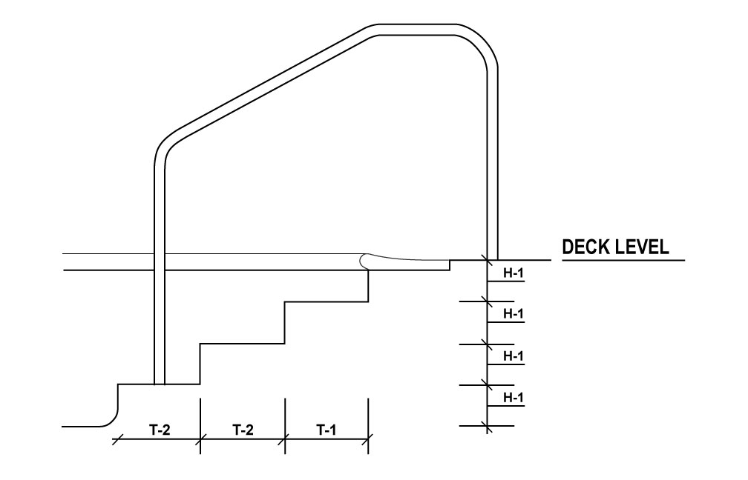
Figure 4.5.4.5.2 Stair treads – Front view.
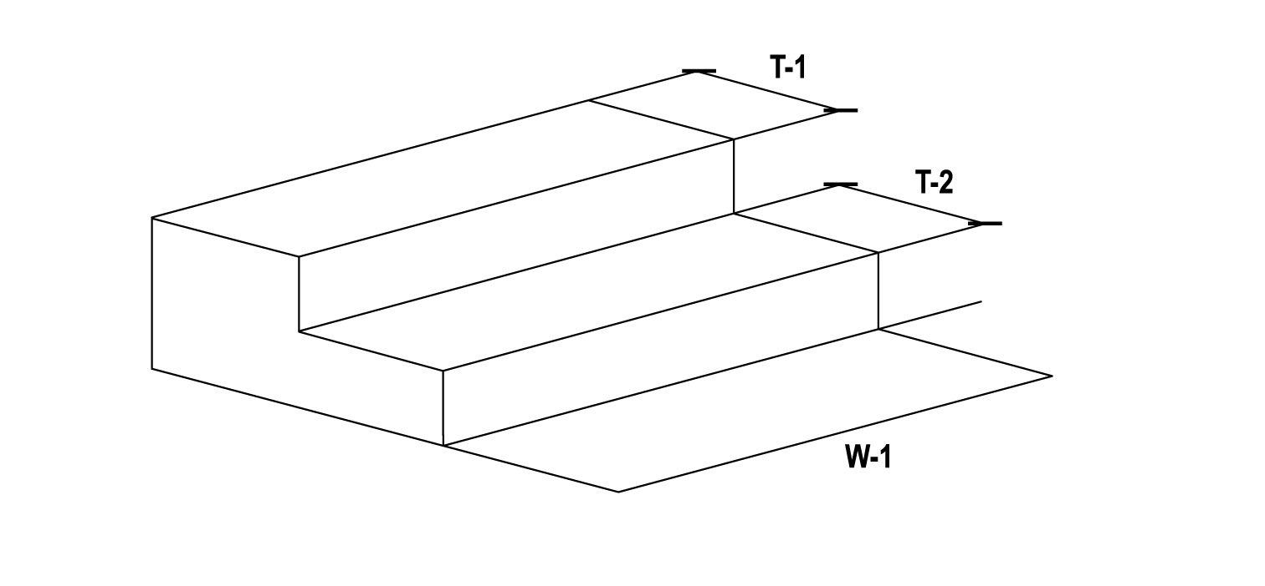
(6) Stair Risers Stair risers shall have a minimum uniform height of 6 inches (15.2 cm) and a maximum height of 12 inches (30.5 cm). Riser construction may vary no more than ½ inch from uniform riser height.
(7) Transitional Areas Stairs shall not be used underwater to transition between two sections of POOL of different depths. The bottom riser may vary due to potential cross slopes with the POOL floor; however, the bottom step riser may not exceed the maximum allowable height required by this section.
(8) Perimeter Gutter Systems For POOLS with PERIMETER GUTTER SYSTEMS, the gutter may serve as a step, provided that the gutter is provided with a grating or cover and conforms to all construction and dimensional requirements herein specified.
WAC 246-261-405050 Handrails (MAHC 4.5.5)
(1) Provided Handrail(s) shall be provided for each set of stairs.
(2) Corrosion Resistant Handrails shall be constructed of corrosion-resistant materials and anchored securely.
(3) Wider Than Five Feet Stairs wider than 5 feet (1.5 m) shall have handrails at either side and spaced not more than every 12 feet (3.7 m) apart across the entire stair width.
(4) Support Handrails shall be designed to resist a load of 50 pounds (22.7 kg) per linear foot applied in any direction and independently a single concentrated load of 200 pounds (90.7 kg) applied in any direction at any location. Handrails shall be designed to transfer these loads through the supports to the POOL or DECK structure.
(5) Dimensions Dimensions of handrails shall conform to requirements of Table 4.5.5.8 and Figure 4.5.5.8.
(6) Anchored Handrails anchored in the pool must anchor on a stair tread.
Table 4.5.5.8 Stair handrail dimensions.
Dimensions | T-1 | H-1
Minimum | 3 inches  (7.6 cm) | 34 inches  (86.4 cm)
Maximum | N/A | 38 inches  (96.5 cm)

Figure 4.5.5.8 Stair handrails – Side view.
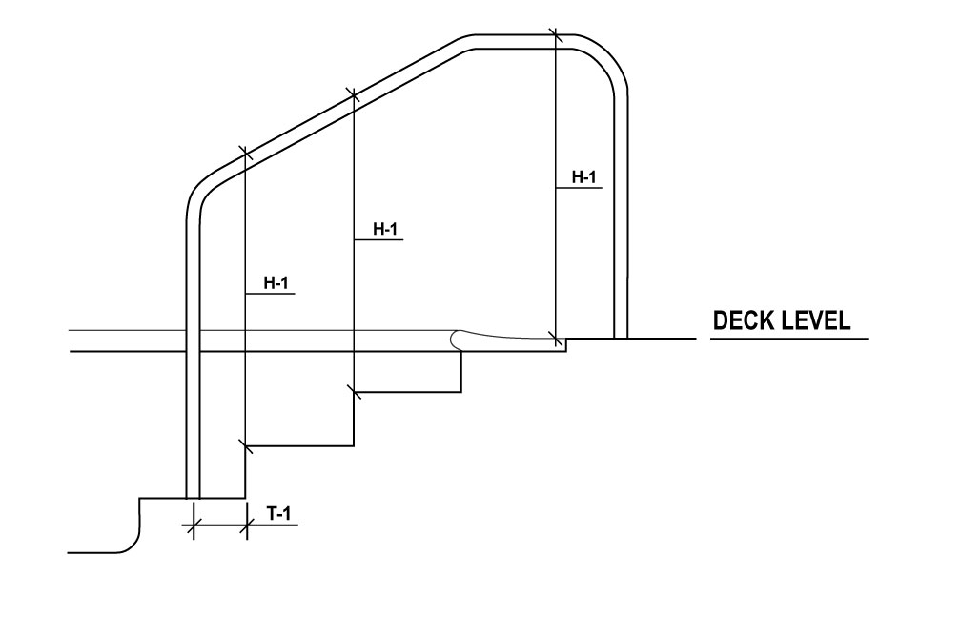
WAC 246-261-405060 Grab Rails (MAHC 4.5.6)
(1) Corrosion Resistant Where grab rails are provided, they shall be constructed of corrosion-resistant materials.
(2) Anchored Grab rails shall be anchored securely to the pool deck.
(3) Provided Grab rails shall be provided at both sides of RECESSED STEPS.
(4) Clear Space The horizontal clear space between grab rails shall be not less than 18 inches (45.7 cm) and not more than 24 inches (61.0 cm).
(5) Upper Railing The upper railing surface of grab rails shall extend above the POOL coping or DECK a minimum of 28 inches (71.1 cm).
(6) Support Grab rails shall be designed to resist a load of 50 pounds (22.7 kg) per linear foot applied in any direction and independently a single concentrated load of 200 pounds (90.7 kg) applied in any direction at any location. Grab rails shall be designed to transfer these loads through the supports to the POOL or DECK structure.
WAC 246-261-405070 Recessed Steps (MAHC 4.5.7)
(1) Slip Resistant Recessed steps shall be SLIP RESISTANT.
(2) Easily Cleaned RECESSED STEPS shall be designed to be easily cleaned.
(3) Drain RECESSED STEPS shall drain into the POOL.
(4) Dimensions Dimensions of RECESSED STEPS shall conform to requirements of:
(a) Table 4.5.7.4,
(b) Figure 4.5.7.4.1, and
(c) Figure 4.5.7.4.2.
Table 4.5.7.4 Recessed step dimensions.
Dimensions | H-1 | H-2 | W-1 | D-1 | D-2
Minimum | 6 inches  (15.2 cm) | 5 inches  (12.7 cm) | 12 inches  (30.5 cm) | 5 inches  (12.7 cm) | N/A
Maximum | 12 inches  (30.5 cm) | N/A | N/A | N/A | 2.5 inches  (6.5 cm)

Figure 4.5.7.4.1 Recessed step dimensions – Side view.
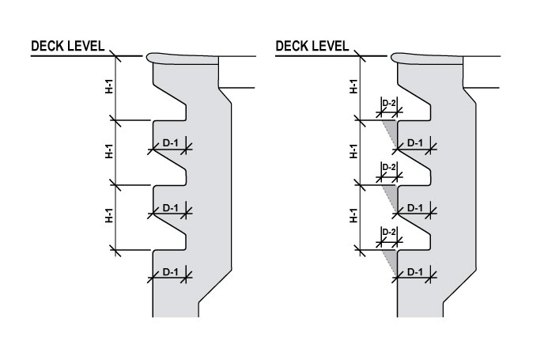
Figure 4.5.7.4.2 Recessed step dimensions – Front view.
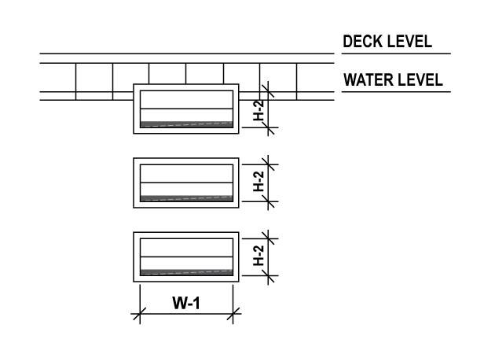
(5) Uniformly Spaced RECESSED STEPS shall be uniformly spaced not less than 6 inches (15.2 cm) and not more than 12 inches (30.5 cm) vertically along the POOL wall.
(6) Perimeter Gutter Systems For POOLS with PERIMETER GUTTER SYSTEMS, the gutter may serve as a step, provided that the gutter is provided with a grating or cover and conforms to all construction and dimensional requirements herein specified.
WAC 246-261-405080 Ladders (MAHC 4.5.8)
(1) General Requirements.
(a) Corrosion Resistant Where provided, ladders shall be constructed of corrosion-resistant materials.
(b) Anchored Ladders shall be anchored securely to the DECK.
(c) Lap Pools Ladders shall not be allowed to protrude into lap lanes in POOLS designed for lap swimming.
(2) Ladder Handrails.
(a) Two Handrails Provided Ladders shall have two handrails.
(b) Clear Space The horizontal clear space between handrails shall be not less than 17 inches (43.2 cm) and not more than 24 inches (61.0 cm).
(c) Upper Railing The upper railing surface of handrails shall extend above the POOL coping or DECK a minimum of 28 inches (71.7 cm).
(d) Pool Wall The clear space between handrails and the POOL wall shall be not less than 3 inches (7.6 cm) and not more than 4 inches (10.2 cm) between the POOL wall and the ladder.
(e) Support Ladders shall be designed to resist a load of 50 pounds (22.7 kg) per linear foot applied in any direction and independently a single concentrated load of 200 pounds (90.7 kg) applied in any direction at any location. Ladders shall be designed to transfer these loads through the supports to the POOL or DECK structure.
(3) Ladder Treads.
(a) Slip Resistant Ladder treads shall be SLIP RESISTANT.
(b) Tread Depth Ladder treads shall have a minimum horizontal tread depth of 1.5 inches (3.8 cm). The distance between the horizontal tread and the POOL wall shall not be greater than 4 inches (10.2 cm).
(c) Uniformly Spaced Ladder treads shall be uniformly spaced not less than 7 inches (17.8 cm) and not more than 12 inches (30.5 cm) vertically at the handrails.
(d) Upmost Ladder Tread The top surface of the upmost ladder tread shall be located not more than 12 inches (30.5 cm) below the POOL coping, gutter, or DECK.
WAC 246-261-405090 Zero Depth (Sloped) Entries (MAHC 4.5.9)
(1) Slip Resistant Where ZERO DEPTH ENTRIES are provided, they shall be constructed with SLIP-RESISTANT materials.
(2) Maximum Floor Slope ZERO DEPTH ENTRIES shall have a maximum floor slope of 1:12, consistent with the requirements of MAHC 4.5.2.1. Changes in floor slope shall be permitted.
(3) Gutter Drains Gutter drains shall be used along ZERO DEPTH ENTRIES at the waterline to facilitate surface skimming.
(a) Flat or Follow Slope The gutters may be flat or follow the slope of the ZERO DEPTH ENTRY.
(b) Handholds Any handholds that present a trip hazard shall not be allowed along the ZERO DEPTH ENTRY.
(4) Rope and Float Line Where the bottom of a POOL slopes from a ZERO DEPTH ENTRY to water depths greater than 3 feet (0.9 m) and includes an area for young non-swimmers to wade and play, a ROPE AND FLOAT LINE shall be installed at the 3 feet (0.9 m) depth to provide a visual and physical separation between the area for toddlers and young non-swimmers and the deeper areas of the POOL. An exception shall be made for WAVE POOLS, SURF POOLS, and WATERSLIDE LANDING POOLS.
WAC 246-261-405010 Access for people with Disabilities (MAHC 4.5.10)
(1) Conform to ADA Standards Access for people with disabilities shall conform to ADA STANDARDS as approved by the Department of Justice.
(2) Pool Lifts All POOL lifts shall be CERTIFIED, LISTED, AND LABELED in accordance with UL 60335-2-1000, and be installed and used in accordance with the manufacturer’s installation instructions and ICC/ANSI A117.1.
WAC 246-261-405011 Color and Finish (MAHC 4.5.11)
(1) White or Light Pastel Floors and walls below the water line shall be white or light pastel in color such that from the POOL DECK a BATHER is visible on the POOL floor and the following items can be identified:
(a) Algae growth, debris, dirt, or other objects within the POOL;
(b) CRACKS in the surface finish of the POOL; and
(c) Reference tiles defined in WAC 246-261-405010(2).
(2) Light Reflectance Value The finish of the pool surface shall meet one of the following:
(a) If the pool surface color in wet condition is provided by the manufacturer.
(i) a wet LRV of 64% or more,
(ii) a wet Munsell Color Value of 8.36 or more, or
(iii) a wet CIE L* value of 84% or more.
(b) If the pool surface color in wet condition is not provided by the manufacturer, but a value is provided for a dry condition,
(i) a dry LRV of 70% or more,
(ii) a dry Munsell Color Value of 8.67 or more, or
(iii) a dry CIE L* value of 87% or more.
(c) If the POOL surface color is not numerically specified by the manufacturer as provided in (a) or (b) of this section, such products shall not be used, or a testing shall be conducted at a laboratory to produce numerical values to ensure that the product meets the requirements in (a) of this section in a manner approved by the department or local health officer.
(d) If a manufacturer provides color values in multiple scales, at least one value must meet the above criteria.
(3) Exceptions An exception shall be made for the following AQUATIC VENUE components:
(a) Competitive lane markings,
(b) Dedicated competitive diving well floors,
(c) Step or bench or ledge or shelf edge markings shall be of in CONTRASTING COLOR,
(d) POOLS shallower than 24 inches (61.0 cm),
(e) Water line tiles,
(f) WAVE POOL and SURF POOL depth change indicator tiles,
(g) Graphics inside of POOL(S) that are used during organized events and are removable at the conclusion of the event, or
(h) SPAS with less than 100 square foot surface area.
WAC 246-261-405012 Walls (MAHC 4.5.12)
(1) Plumb POOL walls shall be plumb within a +/- 3 degree tolerance unless the wall design requires structural support ledges and slopes below to support the upper wall. Refer to Figure 4.5.12.1.
Figure 4.5.12.1 Plumb pool walls – Cross-section.
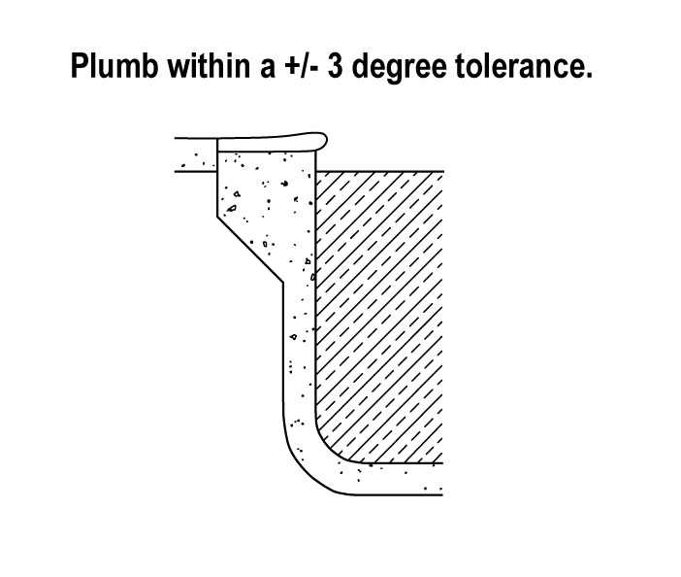
(2) Contrasting Color A CONTRASTING COLOR shall be provided on the edges of any support ledge to draw attention to the ledge for BATHER SAFETY.
(3) Rounded Corners All corners created by adjoining walls shall be rounded or have a radius in both the vertical and horizontal dimensions to eliminate sharp corners.
(4) No Protrusions, Extensions, Means of Entanglement, or Obstructions There shall be no protrusions, extension, means of entanglement, or other obstructions in the AQUATIC VENUE that may cause the entrapment or injury of the user or interfere with proper POOL operation.
(5) Transitional Point Pool sidewalls may not curve or intrude into the pool beyond the vertical more than twelve inches at three and one-half feet and eighteen inches at a depth of five feet. The radius of curvature of wall-floor junctions may not exceed the maximum radius designated in Table 4.5.12.1 of this section for depths over five feet.
Table 4.5.12.1 Maximum radius coving or pool intrusion dimensions between pool floor and wall*.
Pool Depth | 3’ | 3’6” | 5’ | Greater than 5’
Minimum sidewall depth (springline) | 2’2” | 2’6” | 3’6” | At 3’6”
Maximum radius of curvature | 10” | 12” | 1’6” | Maximum radius equals pool depth minus the vertical wall depth
*Note: Y = (1/3)X-2 this formular works in inches. Y is radius of curvature in inches and X is pool depth in inches.
For pool depths falling between depths listed, values can be interpolated.
For pool depths less than three feet and greater than five feet, values shall be extrapolated.
Radius of coving shall not intrude into pool within diving envelope.

WAC 246-261-405014 Handholds (MAHC 4.5.14)
(1) Handholds Provided Where not otherwise exempted, every POOL shall be provided with handholds around the perimeter of the POOL where the water depth at the wall exceeds 24 inches (61.0 cm). These handholds shall be installed not greater than 9 inches (22.9 cm) above, or 3 inches (7.6 cm) below static water level.
(2) Horizontal Recesses Horizontal recesses may be used for handholds provided they are a minimum of 24 inches (61.0 cm) long, a minimum of 4 inches (10.2 cm) high and between 2 inches (5.1 cm) and 3 inches (7.6 cm) deep.
(a) Drain Horizontal recesses shall drain into the POOL.
(b) Consecutive Recesses Horizontal recesses need not be continuous, but consecutive recesses shall be separated by no more than 12 inches (30.5 cm) of wall.
(3) Decking Where PERIMETER GUTTER SYSTEMS are not provided, a coping or cantilevered DECKING of reinforced concrete or material equivalent in strength and durability, with rounded, SLIP-RESISTANT edges shall be provided.
(4) Coping Dimensions The horizontal overhang for coping or cantilevered DECKING shall not be greater than 2 inches (5.1 cm) from the vertical plane of the POOL wall, nor less than 1 inch (2.5 cm).
(5) Coping Thickness The vertical thickness of the coping or cantilevered DECKING shall not exceed 2.5 inches (6.4 cm) for the horizontal overhang.
WAC 246-261-405015 Infinity Edges (MAHC 4.5.15)
(1) Perimeter Restrictions Not more than fifty percent (50%) of the POOL perimeter shall incorporate an INFINITY EDGE detail.
(2) Length The length of an INFINITY EDGE shall be no more than 30 feet (9.1 m) long.
(3) Handholds Handholds conforming to the requirements of WAC 246-261-405014 shall be provided for INFINITY EDGES, which may be separate from, or incorporated as part of the INFINITY EDGE detail.
(4) Overflow Basins Troughs, basins, or capture drains designed to receive the overflow from INFINITY EDGES shall be watertight and free from STRUCTURAL CRACKS. Troughs, basins, or capture drains designed to receive the overflow from INFINITY EDGES shall have a non-toxic, smooth, cleanable, and SLIP-RESISTANT finish.
(5) Maximum Height The maximum height of the wall outside of the INFINITY EDGE shall not exceed 30 inches (76.2 cm) to the adjacent grade and capture drain.
WAC 246-261-405016 Underwater Benches (MAHC 4.5.16)
(1) Slip Resistant Where provided, UNDERWATER BENCHES shall be constructed with SLIP-RESISTANT materials.
(2) Outlined Edges The leading horizontal and vertical edges of UNDERWATER BENCHES shall be outlined in CONTRASTING COLOR with a continuous slip-resistant tile of or other permanent marking of not less than ¾ inch (1.9 cm) and not greater than 2 inches (5.1 cm).
(3) Maximum Water Depth UNDERWATER BENCHES may be installed in areas of varying depths, but the maximum POOL water depth in that area shall not exceed 5 feet (1.5 m).
(4) Maximum Seat Depth The maximum submerged depth of any seat or sitting bench shall be 20 inches (50.8 cm) measured from the water line.
(5) Recessed UNDERWATER BENCHES shall be recessed into POOL walls and shall not protrude into a pool to pose collision hazard and shall not exceed 20% of the length of the side it is located on.
(6) No Diving UNDERWATER BENCHES must be labeled with “NO DIVING” markers on the deck above the bench and in compliance with WAC 246-261-405019(4).
(7) Hydrotherapy Jets UNDERWATER BENCHES may have hydrotherapy jets in SPAS only.
(8) Lap Pools UNDERWATER BENCHES may not be located in an area that is designed for lap swimming.
WAC 246-261-405017 Underwater Ledges (MAHC 4.5.17)
(1) Slip Resistant Where UNDERWATER LEDGES are provided to enable swimmers to rest or to provide structural support for an upper wall, they shall be constructed with SLIP-RESISTANT materials.
(2) Protrude UNDERWATER LEDGES for resting that are recessed or protrude beyond the vertical plane of the POOL wall shall meet the criteria for SLIP RESISTANT and tread depth outlined in this section.
(3) Five Feet or Greater UNDERWATER LEDGES for resting shall only be provided within areas of a POOL with water depths of 5 feet (1.5 m) or greater.
(a) Underwater Toe Ledge UNDERWATER LEDGES shall start no earlier than 4 lineal feet (1.2 m) to the deep side of the 5 foot (1.5 m) slope break.
(b) Below Water Level UNDERWATER LEDGES shall be at least 4 feet (1.2 m) below static water level.
(4) Structural Support UNDERWATER LEDGES for structural support of upper walls shall be allowed.
(a) Ledge Slope All structural support ledges and slopes of the wall below shall fall within a plane sloped at a maximum of 1 horizontally in 5 vertically or 11 degrees from the water line down to a water depth of 5 feet (1.5 m). Refer to Figure 4.5.17.4.
(b) Ledge Depth A structural support ledge shall be installed at a water depth of 3 feet (0.9 m) or deeper.
Figure 4.5.17.4 Structural support ledges.
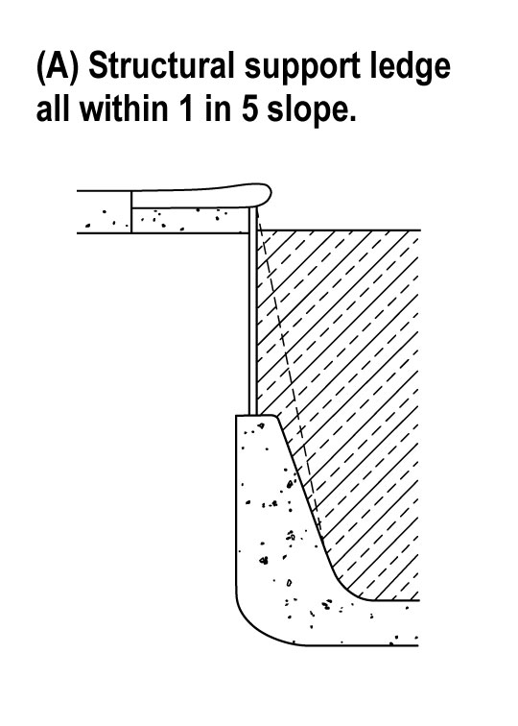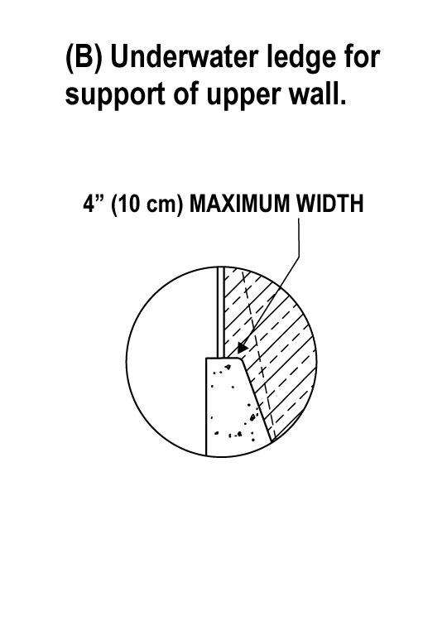
(5) Outlined The edges of UNDERWATER LEDGES and underwater structural support ledges shall be outlined with a continuous SLIP-RESISTANT, CONTRASTING COLOR, tile or other permanent marking of not less than 1 inch (2.5 cm) and not greater than 2 inches (5.1 cm). If they project past the plane of the POOL wall, the edges of UNDERWATER LEDGES and underwater structural support ledges shall be clearly visible from the DECK.
(6) Tread Depths UNDERWATER LEDGES and underwater structural support ledges shall have a maximum uniform horizontal tread depth of 4 inches (10.2 cm). See Figure 4.5.17.4.
WAC 246-261-405018 Underwater Shelves (MAHC 4.5.18)
[Still under construction]
WAC 246-261-4050XX Ballet Rails (WAC 246-260-091(8))
(1) Limited Use Owners may install ballet-type rails on pools having uses limited to exercise and training.
(2) Corrosion Resistant Ballet rails shall be constructed of corrosion-resistant materials and anchored securely.
(3) Support Ballet rails shall be designed to resist a load of 50 pounds (22.7 kg) per linear foot applied in any direction and independently a single concentrated load of 200 pounds (90.7 kg) applied in any direction at any location. Ballet rails shall be designed to transfer these loads through the supports to the POOL or DECK structure.
(4) Hazards If ballet rails are provided, they shall be designed so that they do not cause entrapment, pinching, or collision hazards.
WAC 246-261-405019 Deck Markers and Markings (MAHC 4.5.19)
(1) Location.
(a) Markings POOL water depths shall be clearly and permanently marked at the following locations:
(i) Minimum depth,
(ii) Maximum depth,
(iii) On both sides and at each end of the POOL,
(iv) Placed on all major deviations in shape, and
(v) At the break in the floor slope between the shallow and deep portions of the POOL.
(b) Depth Measurements Depth markers shall be located on the vertical POOL wall and positioned to be read from within the POOL.
(c) Below Handhold Where depth markings cannot be placed on the vertical wall above the water level, other means shall be used so that the markings will be plainly visible to persons in the POOL.
(d) Coping or Deck Depth markers shall also be located on the POOL coping or DECK within 18 inches (45.7 cm) of the POOL structural wall or perimeter gutter.
(e) Read on Deck Depth markers shall be positioned to be read while standing on the DECK facing the POOL.
(f) Twenty-Five Foot Intervals Depth markers shall be installed at not more than 25 (7.6 m)-foot intervals around the POOL perimeter edge and according to the requirements of this section.
(g) Five Feet or Less For water less than 5 feet (1.5 m) in depth, the depth shall be marked at 1 foot (30.5 cm) depth intervals.
(2) Construction size.
(a) Durable Depth markers shall be constructed of a durable material resistant to local weather conditions.
(b) Slip Resistant Depth markers shall be SLIP RESISTANT when they are located on horizontal surfaces.
(c) Color and Height Depth markers shall have letters and numbers with a minimum height of 4 inches (10.2 cm) of a color contrasting with background.
(d) Feet and Inches Depth markers shall be marked in units of feet and inches.
(i) Abbreviations Abbreviations of “FT” and “IN” may be used in lieu of “FEET” and “INCHES.”
(ii) Symbols Symbols for feet (‘) and inches (“) shall not be permitted on water depth signs.
(iii) Metric Metric units may be provided in addition to, but not in lieu of, units of feet and inches.
(3) Tolerance Depth markers shall be located to indicate water depth to the nearest 3 inches (7.6 cm), as measured from the POOL floor 3 feet (0.9 m) out from the POOL wall to the gutter lip, mid-point of surface SKIMMER(S), or surge weir(s).
(4) No Diving Markers.
(a) Depths For POOL water depths 5 feet (1.5 m) or shallower, all DECK depth markers required by WAC 246-261-405019 shall be provided with “NO DIVING” warning signs along with the universal international symbol for “NO DIVING.”
(b) Spacing “NO DIVING” warning signs and symbols shall be spaced at no more than 25 foot (7.6 m) intervals around the POOL perimeter edge.
(c) Durable NO DIVING MARKERS shall be constructed of a durable material resistant to local weather conditions.
(d) Slip Resistant NO DIVING MARKERS shall be SLIP RESISTANT when they are located on horizontal surfaces.
(e) At Least Four Inches All lettering and symbols shall be at least 4 inches (10.2 cm) in height.
(5) Depth Marking at Break in Floor Slope.
(a) Over Five Feet For POOLS deeper than 5 feet (1.5 m), a line of CONTRASTING COLOR, not less than 2 inches (5.1 cm) and not more than 6 inches (15.2 cm) in width, shall be clearly and permanently installed on the POOL floor at the shallow side of the break in the floor slope, and extend up the POOL walls to the waterline.
(b) Durable Depth marking at break in floor slope shall be constructed of a durable material resistant to local weather conditions and be SLIP RESISTANT.
(c) Rope and Float Line One foot (30.5 cm) to the shallower side of the break in floor slope and CONTRASTING COLOR line band, a ROPE AND FLOAT LINE shall extend across the POOL surface with the exception of WAVE POOLS, SURF POOLS, and WATERSLIDE LANDING POOLS. ROPE AND FLOAT LINE must have a receptacle for receiving the safety line either recessed into the wall or constructed so as not to constitute a safety hazard when the safety line is removed.
(6) Dual Marking System Symmetrical AQUATIC VENUE designs with the deep point at the center may be allowed by providing a dual depth marking system which indicates the depth at the wall as measured in WAC 246-261-405019(3) and at the deep point.
(7) Controlled Access Non-Traditional Aquatic Venues Controlled-access AQUATIC VENUES (such as ACTIVITY POOLS, LAZY RIVERS, and other AQUATIC VENUES with limited access) shall require depth markers on a sign at points of entry.
(a) Clearly Visible Depth marker signs shall be clearly visible to PATRONS entering the AQUATIC VENUE.
(b) Lettering and Symbols All lettering and symbols shall be as required for other types of depth markers.
(8) Wading Pool Depth Markers AQUATIC VENUES where the maximum water depth is 6 inches (15.2 cm) of water or less (such as WADING POOLS and ACTIVITY POOL areas) shall not be required to have depth markings or “NO DIVING” signage.
(9) Movable Floor Depth Markers For AQUATIC VENUES with movable floors, a sign indicating movable floor and/or varied water depth shall be provided and clearly visible from the DECK.
(a) Vertical Measurement The posted water depth shall be the water level to the floor of the AQUATIC VENUE according to a vertical measurement taken 3 feet (0.9 m) from the AQUATIC VENUE wall.
(b) Signage A sign shall be posted to inform the public that the AQUATIC VENUE has a varied depth and refer to the sign showing the current depth.
(10) Spas A minimum of two depth markers, conspicuously visible from all points of entry, shall be provided regardless of the shape or size of the SPA as per WAC 246-261-4012XX (MAHC 4.12.1.6).

Subpart X: Decks and Equipment
WAC 246-261-408010 General standards for all decks (2023 MAHC 4.8.1)
(1) Lifeguard placement and safety considerations. DECKS shall be designed to allow for QUALIFIED LIFEGUARD placement per the zone of BATHER surveillance in WAC 246-261-603010 and safety areas and equipment in WAC 246-261-408050.
(a) Access points. Access points shall be provided to QUALIFIED LIFEGUARDS to transit to QUALIFIED LIFEGUARDS positions.
(b) Deck clearance. DECKS shall have a minimum clearance from AQUATIC VENUE edge to fencing or other obstruction as specified in WAC 246-261-408015 for PERIMETER DECKS for POOLS and WAC 246-261-4012XX for other AQUATIC VENUES.
(i) DECK clearances between AQUATIC VENUES must be at least six feet wide.
(ii) AQUATIC VENUES 1,500 square feet or more, DECK surfaces must be at least 16 square feet per BATHER. To determine THEORETICAL PEAK OCCUPANCY, see WAC 246-261-XXXXXX.
(iii) If the owner provides STADIUM SEATING, THEORETICAL PEAK OCCUPANCY may be used in lieu of the required DECK surfaces as described under (b)(ii) of this subsection.
(2) Joints or gaps. Conditions between adjacent DECK materials, components, and concrete pours shall not have horizontal open joints or gaps larger than 3/16 inches wide (4.8 mm).
(a) Vertical elevation. Any change in vertical elevation between adjacent DECK materials, components, and concrete pours exceeding 1/4 inches (6.4 mm) shall be considered an edge condition and shall be treated according to (b) or (c) of this subsection.
(b) Fillers. Open joints or gaps larger than 3/16 inches (4.8 mm) wide or with vertical elevations exceeding 1/4 inches (6.4 mm) shall be rectified using appropriate fillers.
(c) Sealants. The use of fillers such as caulk or sealant in joints or gaps shall be permitted for expansion and contraction.
(d) No violation. The use of fillers such as caulk or sealant in joints or gaps shall not be in violation of this subsection.
(3) Rounded edges. All DECK edges shall be beveled, rounded, or otherwise relieved to eliminate sharp corners.
(4) Minimize cracks. Joints in DECK shall be provided to minimize the potential for CRACKS due to a change in elevation, for movement of the slab and for shrinkage control.
(5) Concrete decking. Where concrete is used as a DECK material, it shall be installed in accordance with the latest edition of the American Concrete Institute (ACI) Standards and in accordance with applicable local, state, territorial, federal, and tribal building CODES.
(6) Access hatches. Any access hatches located within the surface of the DECK shall be lockable, SLIP RESISTANT, and designed to maintain acceptable surface temperatures to allow barefoot traffic.
WAC 246-261-408012 Standards for perimeter decks (2023 MAHC 4.8.1.2)
(1) Impervious. Finish materials for the PERIMETER DECK shall be suitable for the POOL environment, nontoxic, and substantially impervious.
(2) Watertight expansion. Continuous watertight EXPANSION JOINT material shall be provided between PERIMETER DECKS and POOL coping.
(a) Expansion joint. Where applicable, the EXPANSION JOINT shall be designed and constructed so as to protect the coping and its mortar bed from damage as a result of movement of adjoining DECK.
(b) Watertight expansion. All conditions between adjacent concrete PERIMETER DECK pours shall be constructed with watertight EXPANSION JOINTS.
(c) Joint measurements. Joints shall be at least 3/16 inches (5 mm) in continuous width.
(d) Vertical differential. The maximum allowable vertical differential across a joint shall be 1/4 inches (6.5 mm).
WAC 246-261-408013 Drains (2023 MAHC 4.8.1.3)
Refer to WAC 246-261-4011XX for additional guidance on drains.
(1) Slope. DECKS shall be sloped away from the AQUATIC VENUE and in accordance with Table 408013.1 4.8.1.3 below.
Table 408013.1 Minimum Slopes for Drainage
Surface | Minimum Slope
Smooth finishes  (Such as tile, hand-finished concrete, and lightly-broomed concrete) | 1/8 inch per foot  (3.2 mm/30.5 cm)
Moderately textured finishes  (Such as exposed aggregate or medium-broomed concrete) | 1/4 inch per foot  (6.4 mm/30.5 cm)
Heavily textured finishes  (Such as brick, where permitted) | 3/8 inch per foot  (9.5 mm/30.5 cm)
(a) Accessible routes. Where DECK areas or portions thereof serve as ACCESSIBLE ROUTES, slopes in any direction shall not exceed ADA requirements. Heavily textured finishes per Table 408013.1 may not be a part of an ACCESSIBLE ROUTE.
(b) All water. All water that touches areas defined as DECK, including water originating in the AQUATIC VENUE, shall drain effectively to either perimeter areas or to DECK drains.
(c) Remove wastewater. Drainage shall remove AQUATIC VENUE water that splashes outside of the AQUATIC VENUE and beyond a POOL gutter system, DECK cleaning water, and rain water without leaving standing water.
(2) Placement. The placement of DECK drains, where provided, shall effectively carry water away from the AQUATIC VENUE and off the DECK without ponding.
(3) Cross-connection control. There shall be no direct connection between the DECK drains and the sanitary or storm sewer system.
(4) Discharge to sewer or other ground water. If the AHJ requires an outdoor POOL to have DECK drains that discharge to a storm sewer system, ground surface, or holding pond, the POOL shall be plumbed through an air-gap, BACKFLOW preventer, or other approved device as allowed by the AHJ.
(5) No drain. DECK drains shall not drain to the POOL, POOL gutter, or RECIRCULATION SYSTEMS.
(6) Drain bodies. Drain receptacles shall consist of noncorrosive or corrosion-resistant materials.
(7) Drain covers. Drain covers shall be suitable for bare foot traffic with openings no greater than 1/2 inch (1.3 cm) and easily removable with a simple tool to facilitate regular cleaning.
WAC 246-261-408014 Materials/slip resistant (2023 MAHC 4.8.1.4)
(1) General. PERIMETER DECK and POOL DECK shall be constructed with a uniform and easily cleaned surface such as concrete, tile, manufactured, or acrylic surfaces.
(2) Slip resistant. All DECKS shall have SLIP-RESISTANT, textured finishes, which are not conducive to slipping under contact of bare feet in wet or dry conditions.
(3) Carpet. Carpet and artificial turf shall be prohibited materials for PERIMETER DECK and POOL DECK.
(4) Wood. Wood shall be a prohibited material for use as PERIMETER DECK.
(5) Dry deck. DRY DECK shall be easily maintained and not create a public health hazard.
(a) Not required. DRY DECK shall not be required to be hard-paved or impervious.
(b) Wood decking. Wood DECKING may be permitted for DRY DECK.
(6) Landscaping. Loose plant material or bedding shall not be permitted within PERIMETER DECKS. Stable materials are permitted.
WAC 246-261-408015 Deck size/width (2023 MAHC 4.8.1.5)
(1) Perimeter decks. PERIMETER DECKS for all POOLS are subject to the following:
(a) Pools less than 1,500 square feet. For POOLS less than 1,500 square feet, PERIMETER DECKS must be at least four feet wide around the entire perimeter of pools and including:
(i) Six feet wide at the shallow end of a POOL; and
(ii) Six feet wide on a minimum of 25 percent of the deck space of an irregular shaped POOL.
(b) Pools greater than 1,500 square feet. For POOLS 1,500 square feet or larger, PERIMETER DECKS must be at least six feet wide:
(i) Around the entire perimeter of outdoor POOLS;
(ii) On 50 percent of the perimeter of indoor POOLS; and
(iii) The remaining 50 percent perimeter of the indoor POOL must be a minimum of four feet wide.
(c) Circulation path. Perimeter DECK may serve as part of the CIRCULATION PATH.
(d) Flush with pool wall. PERIMETER DECK areas shall be flush with POOL walls/copings except where special conditions exist, such as elevated beam or parapet, raised transfer walls, or as permitted by other sections of this chapter.
(e) Perimeter decking. PERIMETER DECKS shall be provided around 100 percent of the AQUATIC VENUE perimeter except where special conditions exist as permitted by other sections of this chapter.
(f) Spectator seating. Refer to WAC 246-261-406010 for more information on spectator areas.
(2) Fixed equipment.
(a) Unobstructed deck. Unobstructed DECK area four feet (1.2 m) minimum in width shall be provided for access around:
(i) Diving equipment;
(ii) Special feature stairways (such as a WATERSLIDE);
(iii) Lifeguard stands;
(iv) Diving boards;
(v) Similar DECK equipment;
(vi) ADA access equipment; and
(vii) Structural columns.
Exception. DECKS not less than four feet (1.2 m) in width may be provided on the sides and rear of any diving, ADA access, lifeguard stands, and similar DECK equipment.
(b) Circulation path. This unobstructed area may overlap the CIRCULATION PATH.
(c) Queuing space. Where reasonably anticipated, queuing space shall be provided at applicable equipment to minimize encroachment into the CIRCULATION PATH.
(d) Free space. Free area around equipment may consist of PERIMETER DECK and/or POOL DECK, as applicable.
(3) Circulation path.
(a) Conformance. A continuous and unobstructed CIRCULATION PATH shall be provided in conformance with ADA requirements for an ACCESSIBLE ROUTE.
(b) Equipment and furniture. DECK furniture locations shall be designed not to intrude upon any CIRCULATION PATH.
(c) Connect. CIRCULATION PATHS shall connect all site amenities, entrances, and exits as required by ADA.
(d) Deck types. CIRCULATION PATHS may consist of any combination of permitted DECK types.
WAC 246-261-408016 Wing walls or peninsulas (2023 MAHC 4.8.1.6)
(1) No perimeter. Deck WING WALLS or PENINSULAS less than 18 inches (45.7 cm) in width shall not be considered a part of the PERIMETER DECK.
(a) Use by lifeguards. A WING WALL or PENINSULA greater than 18 inches (45.7 cm) wide but less than 48 inches (1.2 m) wide may be used by QUALIFIED LIFEGUARD personnel but shall not be considered as part of the PERIMETER DECK.
(b) Slip resistant. Any WING WALL or PENINSULA shall be constructed of SLIP-RESISTANT materials.
(2) Perimeter overflow system. If it is impractical to design a perimeter overflow system into the WING WALL or PENINSULA due to width or height, then the overflow system may bypass the WING WALL or PENINSULA engineering justification must be provided by the DESIGN PROFESSIONAL and approved by the AHJ.
(3) Pool perimeter and calculation. WING WALLS and PENINSULAS shall be considered part of the POOL. WING WALLS and PENINSULAS shall not be accounted for in calculating the POOL perimeter.
(4) Normal operating water level. WING WALLS and PENINSULAS shall be at or above the normal operating water level of the POOL.
(5) Deck drainage. DECK drainage shall not be required for WING WALLS or PENINSULAS as they are considered part of the POOL. The tops shall be crowned to prevent standing water and sloped to the POOL or overflow system.
(6) Vertical depth markers. Vertical depth markers shall be provided around WING WALLS and PENINSULAS in accordance with WAC 246-261-405019.
WAC 246-261-408017 Islands (2023 MAHC 4.8.1.7)
(1) Minimum width. An ISLAND not more than 18 inches (45.7 cm) in width shall be designed to discourage a person from walking on the ISLAND by not providing stairs, ladders, or bridges to the ISLAND.
(2) Slip resistant. The surface of ISLANDS shall be SLIP RESISTANT.
(3) Lifeguards. An ISLAND 18 inches (45.7 cm) to 48 inches (1.2 m) wide may be allowed for use only by QUALIFIED LIFEGUARDS.
(4) Vertical depth markers. Vertical depth markers shall be provided around ISLANDS in accordance with WAC 246-261-405019 and visible from all sides.
(5) Horizontal depth markers and warning signs. Horizontal depth markings and warning signs shall also be required per WAC 246-261-405019 if the ISLAND is designed for BATHER use. If the ISLAND is not designed for BATHER use, warning signs stating "No Entry" shall be required.
(6) Bridge or stairway. An ISLAND designed for BATHER traffic shall be accessible by bridge, ramp, ladder, or stairway from the POOL.
(7) Minimum clearance. All bridges spanning a POOL or any other structures not intended for INTERACTIVE WATER PLAY AQUATIC VENUE shall have a minimum clearance of four feet (1.2 m) from the POOL surface to any structure overhead.
(8) Guard rails. Any bridge shall have a minimum 42 inch (1.1 m) high BARRIER on both sides that prohibit a four-inch sphere passing through.
WAC 246-261-408018 Heated decks (2023 MAHC 4.8.1.8)
(1) Freeze protection. Where heated DECKS are provided for the purpose of freeze protection, the extent of heated area shall minimally include the entire required PERIMETER DECK and required CIRCULATION PATH(s).
(2) Clearly delineated. Heated DECK paths shall be clearly delineated with respect to unheated DECKS.
WAC 246-261-408019 Hose bibbs (2023 MAHC 4.8.1.9)
(1) General. Domestic water hose bibbs shall be provided in sufficient quantity, spacing, and type to wash down PERIMETER DECK and POOL DECK areas using a hose of no longer than 100 feet (30.5 m).
(2) Backflow prevention. All hose bibbs shall be equipped with BACKFLOW prevention devices.
WAC 246-261-408020 Diving boards and platforms (2023 MAHC 4.8.2)
(1) Diving envelope.
(a) Competitive diving. Diving boards shall be permitted only when the diving envelope conforms to the most current version of STANDARDS for the certifying agency that regulates competitive diving at the AQUATIC FACILITY. Such certifying agencies include:
(i) NCAA;
(ii) NFHS;
(iii) FINA; or
(iv) U.S.A. Diving, Inc.
(b) Noncompetitive diving. If the AQUATIC VENUE does not have competitive diving, then the diving envelope shall conform to the diving envelope STANDARDS of:
(i) Table 408020.1 of this section;
(ii) Table 408020.2 of this section;
(iii) Figure 408020.3 of this section; and
(iv) Figure 408020.4 of this section.
(2) Steps and guardrails.
(a) Higher than 21 inches. Diving stands higher than 21 inches (53.3 cm) measured from the DECK to the top of the butt-end of the board or platform shall have steps or a ladder and handrails.
(b) Self-draining treads. Steps or ladder treads shall be self-draining, corrosion resistant, SLIP RESISTANT, and designed to support the maximum expected load.
(c) Short platforms. Diving stands or platforms that are one meter (3.4 ft) or higher shall be protected with guard rails at least 30 inches (76.2 cm) above the board, extending at least to the edge of the water along with intermediate rails.
(d) Tall platforms. Diving stands or platforms that are two meters (6.6 ft) or higher shall have guard rails with the top rail at least 36 inches (0.9 m) above the board and a second rail approximately half the distance from the platform to the upper rail.
Table 408020.1: Diving Board Height and Dimensions
Diving Board Height | 1.64 ft  (0.5 m) | 2.46 ft  (0.75 m) | 3.28 ft  (1.0 m) | 9.84 ft  (3.0 m)
Diving Board Length | 10.0 ft  (3.05 m) | 12.0 ft  (3.66 m) | 16.0 ft  (4.88 m) | 16.0 ft  (4.88 m)
Diving Board Width | 20.0 in  (50.8 cm) | 20.0 in  (50.8 cm) | 20.0 in  (50.8 cm) | 20.0 in  (50.8 cm)
Table 408020.2: Minimum Dimensions of Components Related to Diving Wells by Diving Board Height
(Note: Letters below refer to Figures 408020.3 and 408020.4)
 |  | Minimum Dimensions
 | Diving Board Height | 0.5 meter | 0.75 meter | 1.0 meter | 3.0 meter
A | Distance from plummet back to pool wall | 3.0 ft  (0.91 m) | 4.5 ft  (1.37 m) | 6.0 ft  (1.83 m) | 6.0 ft  (1.83 m)
B | Distance from plummet to pool wall at side | 10.0 ft  (3.05 m) | 10.0 ft  (3.05 m) | 10.0 ft  (3.05 m) | 11.5 ft  (3.51 m)
C | Distance from plummet to adjacent plummet | 8.83 ft  (2.69 m) | 8.83 ft  (2.69 m) | 8.83 ft  (2.69 m) | 8.54 ft  (2.60 m)
D | Distance from plummet to pool wall ahead | 26.0 ft  (7.92 m) | 27.83 ft  (8.48 m) | 29.58 ft  (9.02 m) | 33.67 ft  (10.26 m)
E | Height, diving board to ceiling at plummet and distances F and G | 16.0 ft  (4.88 m) | 16.0 ft  (4.88 m) | 16.0 ft  (4.88 m) | 16.0 ft  (4.88 m)
F | Clear overhead distance behind and each side of plummet | 8.0 ft  (2.34 m) | 8.0 ft  (2.34 m) | 8.0 ft  (2.34 m) | 8.0 ft  (2.34 m)
G | Clear overhead distance ahead of plummet | 16.0 ft  (4.88 m) | 16.0 ft  (4.88 m) | 16.0 ft  (4.88 m) | 16.0 ft  (4.88 m)
H | Depth of water at plummet | 9.5 ft  (2.90 m) | 10.75 ft  (3.28 m) | 12.0 ft  (3.66 m) | 12.5 ft  (3.81 m)
J | Distance ahead of plummet to depth K | 12.0 ft  (3.66 m) | 14.25 ft  (4.34 m) | 16.5 ft  (5.03 m) | 19.75 ft  (6.02 m)
K | Depth at distance J ahead of plummet | 8.75 ft  (2.67 m) | 10.0 ft  (3.05 m) | 11.28 ft  (3.44 m) | 12.17 ft  (3.71 m)
L | Distance at each side of plummet to depth M | 8.0 ft  (2.34 m) | 8.13 ft  (2.48 m) | 8.25 ft  (2.51 m) | 9.92 ft  (3.02 m)
M | Depth at distance L on each side of plummet | 9.08 ft  (2.77 m) | 10.33 ft  (3.15 m) | 11.63 ft  (3.54 m) | 12.17 ft  (3.71 m)
N | Maximum slope to reduce height E | 30˚ | 30˚ | 30˚ | 30˚
P | Maximum floor slope to reduce depth ahead of K, to the sides of M, or back to pool wall behind H | 3:1 | 3:1 | 3:1 | 3:1

Figure 408020.3 Diving Platform Longitudinal Section: Side View
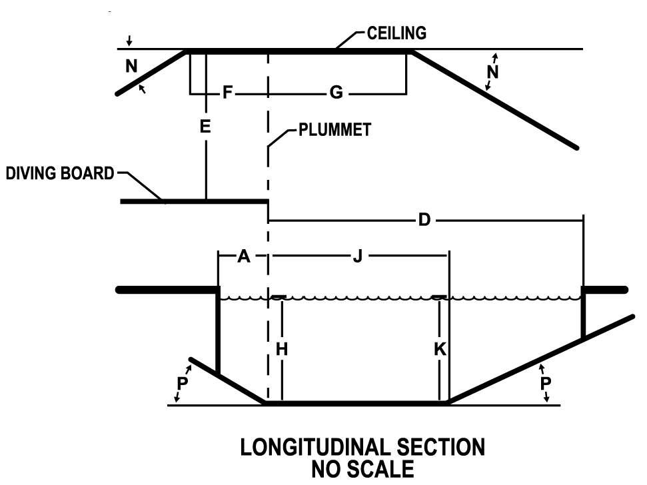
Figure 408020.4 Diving Platform Cross-section: Front View
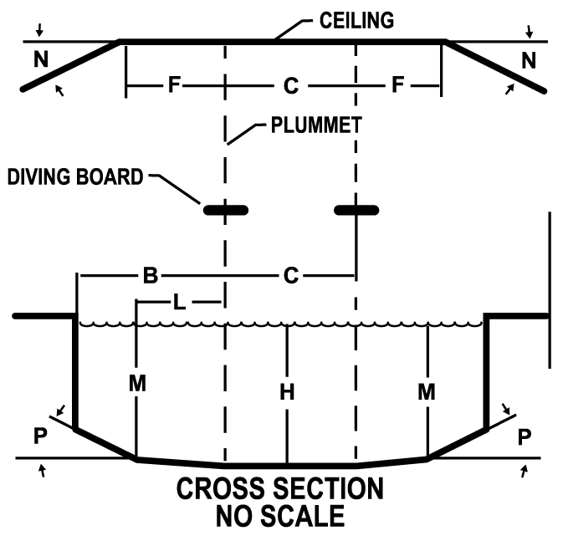

WAC 246-261-408030 Starting platforms (2023 MAHC 4.8.3)
(1) Conform to standard codes. Starting platforms shall be installed and conform to applicable SAFETY STANDARDS established by:
(a) FINA;
(b) U.S.A. Swimming;
(c) NCAA;
(d) NFHS;
(e) YMCA; or
(f) Other sanctioning body.
(2) Minimum water depth. Starting platforms shall be installed in a minimum water depth of four feet (1.25 m), except for new construction, where starting platforms shall be installed in a minimum water depth of six feet (1.8 m).
(3) Leading edge. The leading edge of starting platforms shall have a maximum height of 30 inches (76.2 cm) above the water surface.
(4) Slip resistant. Starting platforms shall have SLIP-RESISTANT tread surfaces.
(5) Secure and stable. Starting platforms shall be installed and secured per manufacturer's recommendations at all times when in use.
WAC 246-261-408050 Lifeguard—Safety-related equipment (2023 MAHC 4.8.5)
(1) Safety equipment required at all aquatic facilities.
(a) Emergency communication equipment. The AQUATIC FACILITY or each AQUATIC VENUE, as necessary, shall have a functional telephone or other communication device that is hard wired and capable of directly dialing 911 or function as the emergency notification system.
(b) Conspicuous and accessible. The telephone or communication system or device must be conspicuously provided and accessible within the AQUATIC VENUE ENCLOSURE and no more than 100 feet walking distance of each AQUATIC VENUE.
(c) Alternate communication systems. Alternate systems, devices, or communication processes are allowed with approval of the AHJ in situations when a telephone is not logistically sound, and an alternate means of communication is available, which meet the requirements of WAC 246-261-50805X.
(d) Internal communication. The AQUATIC FACILITY design shall include a method for staff to communicate in cases of emergency.
(e) Signage. A sign shall be posted at the telephone providing dialing instructions, address and location of the AQUATIC VENUE location, and the telephone number.
(2) Safety equipment required at facilities with lifeguards.
(a) Lifeguard chair and stand placement. The designer shall coordinate with the owner and/or an aquatic consultant to consider the impact on BATHER surveillance zones for placement of chairs and stands designed to be permanently installed so as to provide an unobstructed view of the BATHER surveillance zones.
(b) Lifeguard chair and stand design. The chairs/stands shall be designed:
(i) With no sharp edges or protrusions;
(ii) With sturdy, durable, and UV–resistant materials;
(iii) To provide enough height to elevate the lifeguard to an eye level above the heads of the BATHERS; and
(iv) To provide safe access and egress for the lifeguard.
(c) UV protection for chairs and stands. Where provided, permanently installed chairs/stands, where QUALIFIED LIFEGUARDS can be exposed to UV radiation, shall include protection from such UV radiation exposure.
WAC 246-261-408060 Barriers and enclosures (2023 MAHC 4.8.6)
(1) General requirements.
(a) Enclosure. All AQUATIC FACILITIES, CHEMICAL STORAGE SPACES, and AQUATIC VENUE mechanical spaces shall be located in an ENCLOSURE to prevent unauthorized entry.
(b) Enclosures. The ENCLOSURE may consist of any combination of building envelopes, site walls, or fencing as provided for in this section.
(c) Patron accessibility. An ENCLOSURE shall be provided between CHEMICAL STORAGE SPACES, POOL, mechanical spaces, and areas accessible to the public, in accordance with applicable local, state, territorial, federal, and tribal building CODES.
(2) Construction requirements.
(a) Discourage climbing. BARRIERS or ENCLOSURES shall discourage climbing by providing a 3-foot clearance to nearby structures to simplify climbing over it, such as: Light poles, site furnishings, overhanging tree limbs, or other obvious footholds or handholds.
(b) Horizontal members. Where the ENCLOSURE is composed of horizontal and vertical members:
(i) Horizontal members shall be located on the AQUATIC VENUE side of the ENCLOSURE.
(ii) Where there are decorative cutouts within vertical members, spacing within the cutouts shall not exceed 1 3/4 inches (44 mm) in width.
(iii) When the distance between the tops of the horizontal members is less than 45 inches (1143 mm), spacing between vertical members shall not exceed 1 3/4 inches (44 mm) in width.
(iv) When the distance between the tops of the horizontal members is 45 inches (1143 mm) or more, spacing between vertical members shall not exceed four inches (102 mm) and prevent the passage of a four-inch diameter sphere with the application of 50 pounds of force.
Figure 408060.1 Horizontal members less than 45"
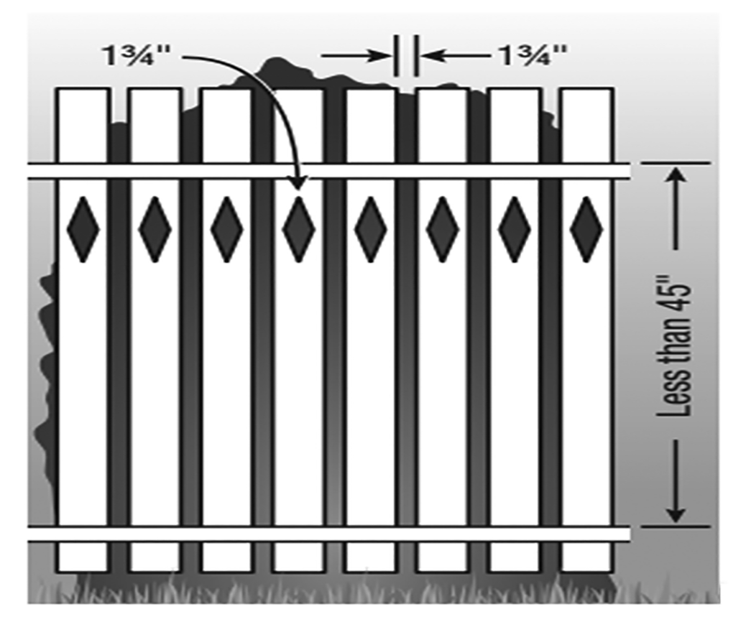

Figure 408060.2 Horizontal members greater than 45"
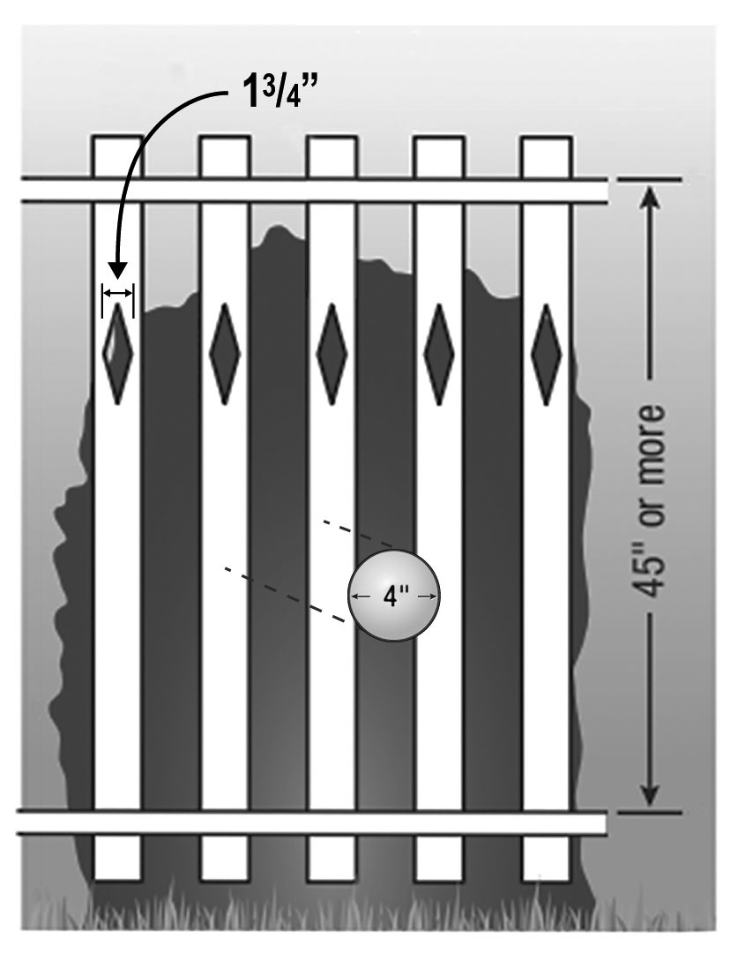
(c) Mesh fencing. The mesh size for chain-link fencing may not exceed 1 1/4 inches (31.7 mm) unless slats, fastened at the top or bottom of the fence, are used to reduce the mesh openings to no more than 1 3/4 inches (44.4 mm).
Figure 408060.3 Mesh fencing
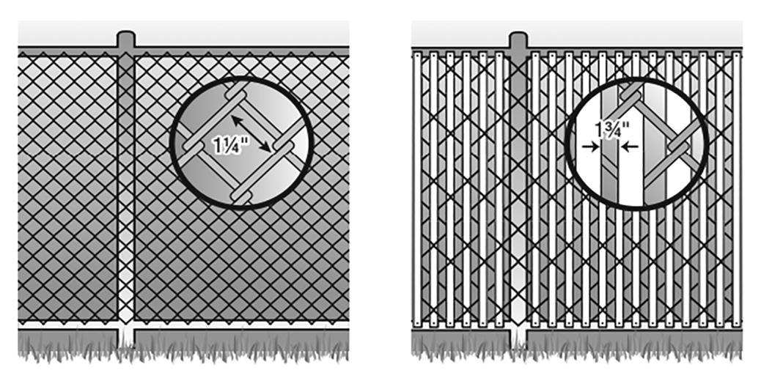
(d) Solid surfaces. Where the enclosure is composed of a solid surface, such as masonry or stone walls, no indentations or protrusions shall be present, other than normal construction tolerances and masonry joints. Such indentations shall not be deeper than 0.375 inches (10 mm).
Figure 408060.4 Solid surfaces
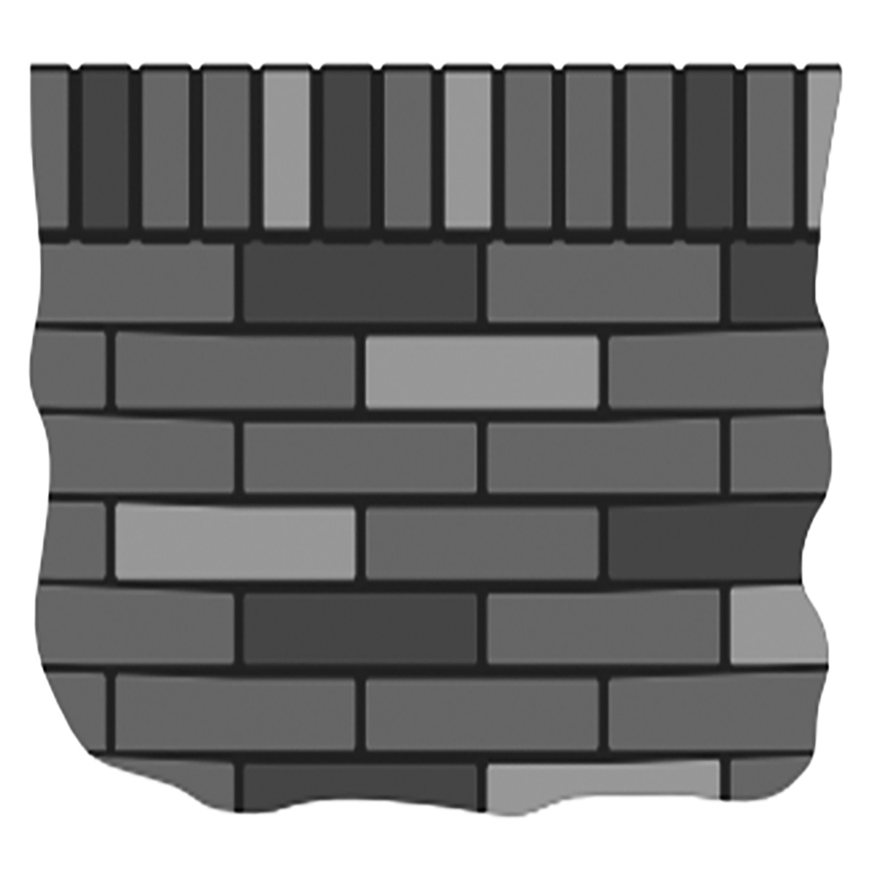
(e) Emergency exit paths. ENCLOSURES for AQUATIC VENUES shall not block or encumber a required emergency egress path from other structures, nor shall emergency egress from other structures not a part of the AQUATIC FACILITY lead into or access an ENCLOSURE for an AQUATIC VENUE.
(f) Windows. Windows having a sill height of less than 72 inches above the pool deck on a building that forms part of an ENCLOSURE around an AQUATIC VENUE shall have a maximum opening width not to exceed four inches (102 mm) and prevent passage of a four-inch diameter sphere with the application of 50 pounds of force. If designed to be opened, windows shall also be provided with a nonremovable screen. A building wall that forms part of an ENCLOSURE around an AQUATIC VENUE shall not have living units on the interior of the ENCLOSURE wall.
(g) Openings. Openings in a BARRIER or ENCLOSURE must not allow the passage of a four-inch diameter sphere with the application of 50 pounds of force.
Figure 408060.5 Openings
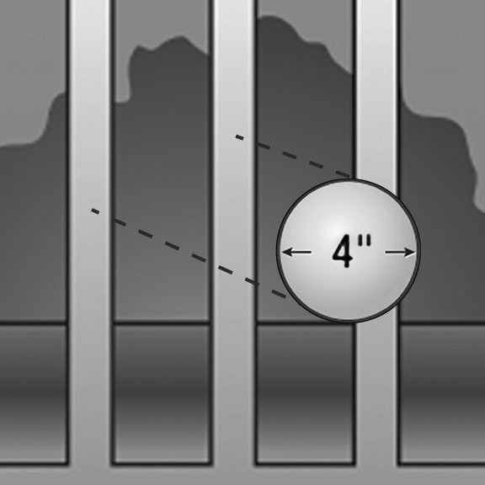
(h) Height. ENCLOSURES shall be no less than six feet (1.83 m) in height.
(i) Change in grade. Where a change in grade occurs at an ENCLOSURE, height shall be measured from the uppermost grade to the top of the ENCLOSURE.
(ii) Fencing requirements. Height shall be measured from the finished grade to the top of the ENCLOSURE on the side outside of the ENCLOSURE surrounding an AQUATIC VENUE.
(iii) Other barriers not serving as part of an enclosure. Except where otherwise noted, all other BARRIERS not serving as part of an AQUATIC FACILITY ENCLOSURE shall not be less than 42 inches (1.1 m) in height.
(i) Clearance above grade. The maximum vertical clearance at the bottom of the AQUATIC VENUE or AQUATIC FACILITY ENCLOSURE when measured on the side of the ENCLOSURE facing away from the enclosed space, shall not exceed:
(i) Two inches (5.1 cm) above grade when the ENCLOSURE rests on a nonsolid surface, including grass or gravel; or
(ii) Four inches (10.2 cm) above grade and prevents the passage of a four-inch diameter sphere when the ENCLOSURE rests on a solid surface.
Figure 408060.6 Clearance above grade
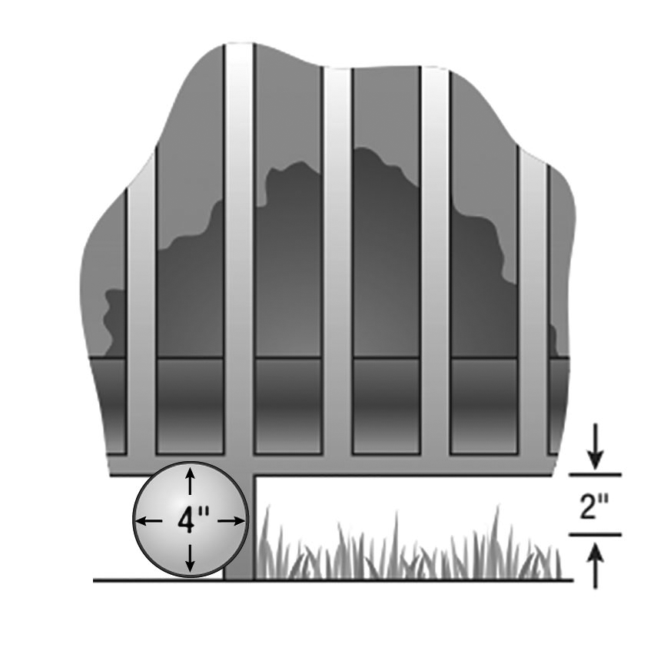
(3) Gates and doors. All gates and doors serving as part of an AQUATIC FACILITY or AQUATIC VENUE are subject to the following:
(a) Self-closing and latching. All public access gates or doors serving as part of an AQUATIC FACILITY ENCLOSURE or AQUATIC VENUE ENCLOSURE shall be self-closing and self-latching from any open position.
(b) Accessible routes. All public access gates or doors serving as part of an AQUATIC FACILITY or AQUATIC VENUE ENCLOSURE and an ACCESSIBLE ROUTE shall be the self-locking type such as where the lock is operated by means of a key, electronic opener, or the entry of a combination into an integral combination lock.
(c) Release latch height and locking requirements. Operable parts of the release latch on:
(i) Self-latching devices that self-lock, the lock operation control and the latch release shall be located not less than 34 inches and not greater than 48 inches above finished grade; and
(ii) Self-latching devices that do not self-lock shall be located a minimum of 60 inches above finished grade from the bottom of the latch release.
(d) Inoperable by children. Self-latching devices shall not be operable by small children on the outside of the ENCLOSURE around the AQUATIC VENUE. A BARRIER is required around a latch less than 60 inches high to prevent activating the latch from outside the ENCLOSURE. The BARRIER must have a minimum 18 inch radius of material around the latch and the material shall not have any openings that exceed 1/2 inch in any dimension.
Figure 408060.7 Inoperable by children
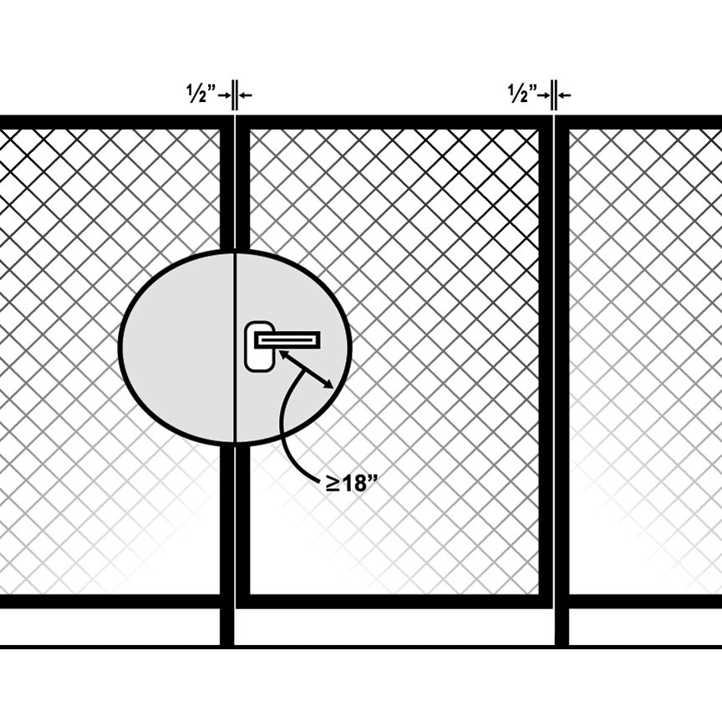
(e) Self-locking device. Self-locking devices must latch and lock automatically when the door or gate returns to a closed position.
(f) Locked. All gates or doors shall be capable of being locked from the exterior.
(g) Emergency egress. Gates or doors shall be designed in such a way that they do not prevent egress in the event of an emergency.
(h) Unauthorized entry. EXIT GATES or doors shall be constructed so as to prevent unauthorized entry from outside of the ENCLOSURE around the AQUATIC VENUE.
(i) Exceptions. The requirements of (a) through (h) of this subsection do not apply when the gate or door of an AQUATIC FACILITY or AQUATIC VENUE ENCLOSURE is part of the AQUATIC VENUE(S) and has a QUALIFIED LIFEGUARD(S) conducting PATRON surveillance at all times, the AQUATIC VENUE(S) is open and the gate or door is locked at all times, the AQUATIC FACILITY or AQUATIC VENUE is not open to the public.
(j) Gates. Gates shall be at least equal in height at top and bottom to the ENCLOSURE of which they are a component.
(k) Turnstiles. Turnstiles shall not form a part of an AQUATIC FACILITY ENCLOSURE.
(l) Exit gates. EXIT GATES shall be conspicuously marked on the inside of the AQUATIC VENUE or AQUATIC FACILITY.
(i) Quantity, location, and width. Quantity, location, and width(s) for EXIT GATES shall be provided consistent with all applicable local, state, territorial, federal, and tribal building and fire CODES and applicable accessibility guidelines.
(ii) Swing outward. EXIT GATES shall swing away from the AQUATIC VENUE ENCLOSURE.
(iii) Absence of building codes. Where local, state, territorial, federal, and tribal building CODES do not otherwise govern, at least one 36-inch (91.4 cm) wide EXIT GATE shall be required for emergency access to each logical AQUATIC VENUE area including individual POOLS or grade levels or both.
(4) Indoor aquatic venues.
(a) Enclosure. Building walls enclosing an INDOOR AQUATIC FACILITY may be designated as the AQUATIC FACILITY ENCLOSURE.
(b) Securable. Indoor AQUATIC VENUES shall be securable from unauthorized entry from other building areas or the exterior.
(c) Indoor and outdoor aquatic venues. Where separate indoor and outdoor AQUATIC VENUES are located on the same site, an AQUATIC VENUE ENCLOSURE shall be provided between them except where all AQUATIC VENUES are operated continuously 12 months a year on the same schedule.
(d) Wall separating. For a passage through a wall separating the indoor portion of an AQUATIC VENUE from an outdoor portion of the same AQUATIC VENUE, the overhead clearance of the passage to the AQUATIC VENUE floor shall be at least six feet eight inches (2.0 m) to any solid structure overhead.
(5) Multiple aquatic venues.
(a) One enclosure. Except as otherwise required in this chapter, one ENCLOSURE may surround multiple AQUATIC VENUES at one facility.
(b) Wading pools. WADING POOLS shall not require separation from other WADING POOLS by a BARRIER. Refer to WAC 246-261-4012XX for additional guidance about WADING POOLS.
WAC 246-261-408070 Aquatic venue cleaning systems (2023 MAHC 4.8.7)
(1) No hazard. The cleaning system provided shall not create an entanglement or suction entrapment hazard or interfere with the operation or use of the AQUATIC VENUE.
(2) Integral vacuum systems. Use of integral vacuum systems, meaning a vacuum system that uses the main circulating pump or a dedicated vacuum pump connect to the POOL with PVC piping and terminating at the POOL with a flush-mounted vacuum port fitting, shall be prohibited.
Subpart X: Equipment Rooms and Chemical Storage
WAC 246-261-409010 Equipment Room (2023 MAHC 4.9.1)
(1) General Requirements. Owners shall provide enclosed, locked, lighted, vented equipment rooms. Owners shall provide a separate chemical storage area or room that conforms to manufacturer's requirements for each chemical used in the pool area.
(a) Nonabsorbent Material. The EQUIPMENT ROOM floor shall be of concrete or other suitable material having a smooth SLIP-RESISTANT finish. The EQUIPMENT ROOM floor shall have positive drainage to floor drains.
(b) Floor Slope. Floors shall have a slope toward the floor drain to prevent standing water at all times.
(c) Opening. The opening to the EQUIPMENT ROOM shall be designed to provide access for all anticipated equipment.
(d) Hose Bibb. At least one hose bibb, shall be located in the EQUIPMENT ROOM or be accessible to it, so that a hose can service the entire EQUIPMENT ROOM.
(2) Construction.
(a) Size. The size of the EQUIPMENT ROOM shall provide working space to perform routine operations and equipment service.
(i) Working Space. Working space around equipment shall be:
(A) compliant with manufacture’s recommendations,
(B) compliant with other applicable codes and standards, and
(C) accessible with no less than 3 feet of clear space above and to at least one side of each piece of equipment.
(D) When equipment can be located to ensure easy access to all serviceable components the requirement for 3 feet of space above the equipment may be reduced.
(ii) Storage Space. EQUIPMENT ROOMS also intended for STORAGE shall have adequate space provided for such STORAGE, without reducing the working spaces.
(b) Lighting. EQUIPMENT ROOMS shall be lighted to provide 30 foot candles (323 lux) of illumination at floor level in accordance with IESNA guidelines.
(3) Markings.
(a) Piping Labeled. Piping including feeds, lines and tubes that convey liquids or gas, in the EQUIPMENT ROOM shall be permanently labeled in a conspicuous location by its use and the AQUATIC VENUE and AQUATIC FEATURE it serves. Identified piping may include but not be limited to:
(i) Main drains
(ii) SKIMMERS,
(iii) Filtered water,
(iv) Make-up water,
(v) Backwash water,
(vi) Chlorine (or DISINFECTION) feeds,
(vii) Acid (or pH) feeds,
(viii) Compressed air lines,
(ix) Gutters,
(x) Chemical sample piping, and
(xi) POOL heating lines
(xii) AQUATIC FEATURE supply.
(b) Piping Flow Marked. All piping, including feeds, lines and tubes that convey liquids or gas, shall be marked with directional arrows to determine typical/operational flow direction.
(c) Valves Identified. All valves shall be clearly identified by number with a brass tag, plastic laminate tags, or permanently affixed alternate.
(i) Valves Described. Valves shall be described as to their function and referenced by identification number in the operating instruction manual.
(ii) Piping Diagram. A water-resistant, easily read, and readily available piping diagram shall be furnished inside the EQUIPMENT ROOM. The piping diagram shall include valve numbers matching the valve chart/list.
(6) Separation from Chemical Storage Spaces.
(a) Equipment.
(i) Contaminated Air. EQUIPMENT ROOMS shall be designed to minimize exposure of combustion equipment, air-handling equipment, and electrical equipment from air contaminated with corrosive chemical vapors or mists.
(ii) Independent Exhaust Systems. CHEMICAL STORAGE SPACES must have an independent exhaust system. EQUIPMENT ROOMS must have an independent exhaust system.
(iii) Isolated Air. Spaces containing combustion equipment, air-handling equipment, and/or electrical equipment and spaces sharing exhaust systems with spaces containing such equipment shall be isolated from CHEMICAL STORAGE SPACE air.
(b) Doors and Openings.
(i) No Doors Between Equipment and Chemical Storage. Doors shall not be installed in a wall between an EQUIPMENT ROOM and an interior CHEMICAL STORAGE SPACE.
(ii) No Openings between equipment and chemical storage. To the extent possible, there shall be no ducts, grilles, pass-throughs, or other openings connecting EQUIPMENT ROOMS to CHEMICAL STORAGE SPACES.
(iii) No Openings to Indoor Aquatic Facility. There shall be no ducts, grilles, pass-throughs, or other openings connecting EQUIPMENT ROOMS or CHEMICAL STORAGE SPACES to an INDOOR AQUATIC FACILITY. HVAC equipment which is designed for use in an INDOOR AQUATIC FACILITY atmosphere and which serves only that INDOOR AQUATIC FACILITY is acceptable.
(iv) Openings / Gaps. Where building construction leaves any openings or gaps between floors and walls, or between walls and other walls, or between walls and ceilings, such gaps shall be permanently sealed against air leakage.
(c) Aquatic Facility Access.
(i) Floor Slope. Where a door or doors must be installed in a wall between an EQUIPMENT ROOM and an INDOOR AQUATIC FACILITY, the floor of the EQUIPMENT ROOM shall slope per all applicable local, state, territorial, federal, and tribal building requirements back into the EQUIPMENT ROOM in such a way as to prevent any EQUIPMENT ROOM spills from running under the door into the INDOOR AQUATIC FACILITY.
(A) Four Inches Exception: This requirement may be met by a floor all of which is at least 4 inches (10.2 cm) below the level of the nearest part of the INDOOR AQUATIC FACILITY floor.
(B) Dike Exception: This requirement may be met by a continuous dike not less than 4 inches (10.2 cm) high located entirely within the EQUIPMENT ROOM, which will prevent spills from reaching the INDOOR AQUATIC FACILITY floor.
(C) Floor Drains. EQUIPMENT ROOMs shall be provided with floor drains.
(ii) Automatic Closer. Such door or doors between an EQUIPMENT ROOM and an INDOOR AQUATIC FACILITY shall be equipped with an automatic closer. The door, frame, and automatic closer shall be installed and maintained so as to ensure that the door closes completely and latches without human assistance.
(iii) Automatic Lock. Such door or doors between an EQUIPMENT ROOM and an INDOOR AQUATIC FACILITY shall be equipped with an automatic lock.
(A) Restrict Access. Such lock shall require a key or combination to open from the INDOOR AQUATIC FACILITY side.
(B) One Hand. Such lock shall be so designed and installed as to be opened by one hand from the inside of the room under all circumstances, without the use of a key or tool.
(iv) Warning Sign. Such doors shall be equipped with permanent signage warning against unauthorized entry.
(v) Gasket. All sides of such doors shall be equipped with a gasket. The gasket shall be so installed as to prevent the passage of air, vapors , or mists when the door is closed.
(vi) Not Relief. This section shall not be construed as granting relief from WAC 246-261-409010(6)(b)(i).
WAC 246-261-409020 Chemical Storage Spaces (2023 MAHC 4.9.2)
(1) Outdoor/Indoor Storage.
(a) Stored Outdoors. If POOL chemicals, acids, salt, oxidizing cleaning materials, or other corrosive or oxidizing chemicals are stored outdoors, they shall be stored in a well-ventilated protective area that shields chemicals from weather impacts and provides storage conditions to meet chemical manufacture’s storage recommendations and with an installed ENCLOSURE to prevent unauthorized access as per WAC 246-261-409020(3).
(b) Minimize Vapors and mists. Where such materials must be stored in a building intended for occupancy, the transfer of chemical vapors and mists from the CHEMICAL STORAGE SPACE to other parts of the building shall be minimized.
(c) Dedicated Space. At least one space dedicated to CHEMICAL STORAGE SPACE shall be provided to allow safe STORAGE of the chemicals present.
(d) Eyewash. In all CHEMICAL STORAGE SPACES, an emergency eyewash station shall be provided and maintained in operating condition in alignment with WAC 296-800-15030. Emergency washing stations should be located outside of any area that could become immediately dangerous to life and health in the case of a chemical release.
(2) Construction.
(a) Foreseeable Hazards. The construction of the CHEMICAL STORAGE SPACE shall take into account the foreseeable hazards.
(i) Adequate Space. The CHEMICAL STORAGE SPACE will provide:
(A) Enough space to store all AQUATIC VENUE chemicals;
(B) Separation between incompatible chemical products; and
(C) A 3-foot-wide minimum access space.
(b) Protected. The construction of the CHEMICAL STORAGE SPACE shall protect the STORED materials against tampering, incompatible chemicals and materials, high humidity, unintended exposure to water, direct sunlight, sources of ignition, and temperature extremes (i.e. 32°F [0°C] and below and/or over 95°F [35°C]).
(c) Floor. The floor or DECK of the CHEMICAL STORAGE SPACE shall be protected against substantial chemical damage by the application of a coating or sealant capable of resisting attack by the chemicals to be stored.
(d) Minimize Vapors and Mists. The construction and operation of a CHEMICAL STORAGE SPACE shall minimize the transfer of chemical vapors and mists into any INTERIOR SPACE of a building intended for occupation.
(e) Surfaces. Any walls, floors, doors, ceilings, and other building surfaces of an interior CHEMICAL STORAGE SPACE shall join each other tightly.
(f) No Openings. There shall be no permanent or semi-permanent opening between a CHEMICAL STORAGE SPACE and any other INTERIOR SPACE of a building intended for occupation unless compliant with WAC 246-261-409020(3)-(5).
(3) Exterior Chemical Storage Spaces.
(a) Enclosure Exterior. CHEMICAL STORAGE SPACES not joined to a wall of a building shall have a complete ENCLOSURE consisting of fencing, or other similar constructed feature that is at least 6 feet (1.8 m) high and meets the non-climbability requirements of WAC 246-261-408060(2)(a).
(c) Gate. Fencing shall be equipped with a self-closing and self-latching gate having a permanent locking device.
(4) Chemical Storage Space Doors.
(a) Signage. All doors and gates opening into CHEMICAL STORAGE SPACES shall be equipped with permanent signage:
(i) Warning against unauthorized entry,
(ii) Specifying the expected hazards,
(iii) Specifying the location of the associated SDS forms, and
(iv) Product chemical hazard NFPA chart.
(b) Emergency Egress. Where a single door or gate is the only means of egress from a CHEMICAL STORAGE SPACE, the door or gate shall be equipped with an emergency-egress device.
(c) Interior Door. Where a CHEMICAL STORAGE SPACE door must open to an INTERIOR SPACE, spill containment shall be provided to prevent spilled chemicals from leaving the CHEMICAL STORAGE SPACE.
(d) Equipment Space. Where a CHEMICAL STORAGE SPACE door must open to an INTERIOR SPACE, the door shall not open to a space containing combustion equipment, air-handling equipment, or electrical equipment. Corrosive. Such door shall be acceptable where all equipment thus exposed is listed for the corrosive atmosphere.
(e) Interior Opening. Where a CHEMICAL STORAGE SPACE door must open to an INTERIOR SPACE, such door shall have all of the following requirements:
(i) Corrosion Resistant. Such doors shall be constructed of corrosion-resistant materials.
(ii) Automatic Lock. Such doors shall be equipped with a corrosion-resistant, automatic lock to prevent unauthorized entry.
(A) Key or Combination. Such lock shall require a key or combination to open from the outside into the CHEMICAL STORAGE SPACE.
(B) Opened. Such lock shall be so designed and installed as to be capable of being opened by one hand from the inside of the CHEMICAL STORAGE SPACE without the use of a key or tool.
(iii) Supported. Such doors shall be supported on corrosion-resistant hinges, tracks, or other supports.
(iv) Air Leakage. Such doors shall be equipped with suitable gaskets or seals on the top and all sides to minimize air leakage between the door and the door frame.
(v) Floor. Such doors shall be equipped with a floor or threshold seal to minimize air leakage between the door and the floor or threshold.
(vi) Automatic Closer. Such doors shall be equipped with an automatic door closer that will completely close the door and latch without human assistance.
(vii) Limit Switch. Such doors shall be equipped with a limit switch and an alarm that will sound if the door remains open for more than 30 minutes.
(A) Alarm. This alarm shall have a minimum output level of 85 dbA, 30 second L₉₀ at 10 feet (3.0 m).
(B) Loss of Air Pressure. Where an open door will result in loss of air-pressure difference, this requirement can be met by the audible alarm required under WAC 246-261-409020(5)(a)(iv).
(5) Interior Chemical Storage Spaces.
(a) No Air Movement. There shall be no transfer grille, pass-through grille, louver, or other device or opening that will allow air movement from the CHEMICAL STORAGE SPACE into any other INTERIOR SPACE of a building intended for occupancy or into another CHEMICAL STORAGE SPACE.
(B) Space Pressurization. CHEMICAL STORAGE SPACES that share any building surface (wall, floor, ceiling, door, etc.) with any other INTERIOR SPACE shall be equipped with a ventilation system that operates continuously and maintain negative pressurization in the CHEMICAL STORAGE SPACE relative to any other INTERIOR SPACE.
(i) Separate Exhaust System. Where more than one CHEMICAL STORAGE SPACE is present, a separate exhaust system shall be provided for each CHEMICAL STORAGE SPACE. The exhaust airflow rate shall be the greater of the:
(A) The Department of Labor and Industries’ requirements for working in such enclosed spaces,
(B) Amount needed to maintain the concentration of vapors or mists below the PEL for the expected exposure time (defined by in chapter 296-841 WAC) for each stored chemical,
(C) Amount specified by International Mechanical Code,
(E) Amount needed to maintain the specified pressure difference.
(iv) Alarm. The function of this exhaust system shall be MONITORED continuously by an audible differential-pressure alarm system which shall sound if the specified differential air pressure is not maintained for a period of 30 minutes.
(A) Minimum Output. This alarm shall have a minimum output level of 85 dbA, 30 second L₉₀ at 10 feet (3.0 m).
(B) Manual Reset. The specified alarm shall require manual reset to silence it.
(6) Air Ducts in Interior Chemical Storage Spaces.
(a) No Air Movement. No duct shall allow air movement from the CHEMICAL STORAGE SPACE into any other INTERIOR SPACE of a building intended for occupation or into any other CHEMICAL STORAGE SPACE.
(b) Chemical Storage. Air ducts shall not enter or pass through an interior CHEMICAL STORAGE SPACE. Except, a corrosion-resistant duct used for no other purpose than to exhaust air from the CHEMICAL STORAGE SPACE or makeup air to the CHEMICAL STORAGE SPACE shall be acceptable. This corrosion-resistant duct shall exhaust to the exterior and must end at a point on the exterior of the building, at least 20 feet (6.1 m) from any air intake for breathing air, cooling air, or combustion air or supply make up air.
(7) Pipes and Tubes in Interior Chemical Storage Spaces.
(a) Not Enter. Pipes and tubes shall not enter or pass through an interior CHEMICAL STORAGE SPACE.
(i) Service Exception: As required to service devices integral to the function of the CHEMICAL STORAGE SPACE, such as pumps, vessels, controls, freeze protection, and safety devices.
(ii) Automatic Fire Suppression Exception: As required to allow for automatic fire suppression where required.
(iii) Drainage Exception: As required for drainage.
(b) Devices. Piping, tubes, drain bodies, grates, and attachment and restraint devices shall be corrosion resistant and rated for the chemical environment(s) present including floor drain bodies and grates.
(c) Wall Penetrations. All wall penetrations shall be sealed air-tight. Sealing material(s) shall be compatible with the wall assembly and the chemical environment(s) present.
(8) Combustion Equipment in Interior Chemical Storage Spaces. No COMBUSTION DEVICE or appliance shall be installed in a CHEMICAL STORAGE SPACE, or in any other place where it will be exposed to the air from a CHEMICAL STORAGE SPACE.
(9) Ozone Rooms.
(a) Only Ozone Equipment. An ozone EQUIPMENT ROOM is required for ozone equipment capable of producing ½ pounds or more of ozone in a 24-hour period and shall not be used for STORAGE of chemicals, solvents, or any combustible materials, other than those required for the operation of the recirculation and ozone generating equipment.
(b) Emergency Ventilation. Rooms which are designed to include ozone equipment shall be equipped with an emergency exhaust ventilation system capable of 6 air changes per hour.
(i) Exhaust Intake. The exhaust intake shall be located approximately 6 inches (15.2 cm) from the floor, on the opposite side of the room from the make-up air intake.
(ii) On Command. The emergency exhaust ventilation system shall be so arranged as to run on command of an ozone-leak alarm or on command of a manual switch.
(iii) Manual Switch. The manual emergency exhaust ventilation switch shall be located outside the room and near the door to the ozone room.
(c) Signage. In addition to the signs required on all CHEMICAL STORAGE SPACES, a sign shall be posted on the exterior of the entry door, stating “DANGER - GASEOUS OXIDIZER – OZONE” in lettering not less than 4 inches (10.2 cm) high.
(d) Alarm System. Rooms containing ozone generation equipment shall be equipped with an audible and visible ozone detection and alarm system.
(i) Requirements. The alarm system shall consist of both an audible alarm capable of producing at least 85 decibels, 30 second L₉₀ at 10 feet distance (3.0 m), and a visible alarm consisting of a flashing light mounted in plain view of the entrance to the ozone-EQUIPMENT ROOM.
(ii) Sensor. The ozone sensor shall be located at a height of 18–24 inches (45.7–61.0 cm) above floor level. The ozone sensor shall be capable of measuring ozone in the range of 0–2 ppm by volume (ppmv or mL/m³).
(iii) Ozone Concentration. The alarm system shall alarm when the ozone concentration equals or exceeds 0.1 ppm by volume (ppmv or mL/m³) in the room.
(iv) Activation. Activation of the alarm system shall shut off the ozone generating equipment and turn on the emergency exhaust ventilation system.
(10) Gaseous Chlorination Space. As per WAC 246-261-4070XX (MAHC 4.7.3.2.4.1), use of compressed CHLORINE gas shall be prohibited for new construction and after ALTERATION to existing AQUATIC FACILITIES.
(a) Existing Facilities. This subsection shall apply to existing facilities using compressed CHLORINE gas.
(b) Adequate Size. A gaseous-chlorination space shall be large enough to house the chlorinator, CHLORINE STORAGE tanks, and associated equipment as required. Have a sign on the door exterior reading DANGER CHLORINE in lettering not less than 4 inches (10.2 cm) high.
(c) Secure Tanks. A gaseous-chlorination space shall be equipped with facilities for securing tanks.
(i) Have taring (net weight of cylinder gas) scales or trunnions for determining chlorine weight.
(ii) Have an approved valve-stem cylinder wrench on the valve stem to shut the system down in an emergency event.
(iii) Be tagged to indicate cylinders are empty or full.
(iv) Not exceed one hundred fifty pounds tare weight per cylinder, except, wave pools, where one-ton cylinders may be used. Only a single, one-ton cylinder shall be stored on the premise at any time.
(v) In pools where compressed chlorine gas is used, means to detect leaks shall be provided, i.e., use of proper strength (26º Baume) ammonia vapor.
(d) Not Below Grade. A gaseous-chlorination space shall not be located in a basement or otherwise be below grade.
(e) Compressed-Chlorine Gas. Where installed indoors, compressed-CHLORINE gas STORAGE containers and associated chlorinating equipment shall be in a separate room constructed to have a fire rating of not less than 1-hour.
(f) Entry Door. The entry door to an indoor gaseous-CHLORINE space shall open to the exterior of the building or structure.
(g) Pool or Deck. The entry door to an indoor gaseous-CHLORINE space shall not open directly towards a POOL or DECK.
(h) Inspection Window. An indoor gaseous-CHLORINE space shall be provided with a shatterproof gas-tight inspection window.
(i) Ventilation. Indoor gaseous-chlorination spaces shall be provided with a spark-proof ventilation system capable of 60 air changes per hour.
(i) Exhaust-Air Intake. The exhaust-air intake of the ventilation system shall be taken at a point within 6 inches (15.2 cm) of the floor, and on the opposite side of the room from the makeup-air intake.
(ii) Discharge Point. The exhaust-air discharge point shall be:
(A) Outdoors,
(B) Above adjoining grade level,
(C) At least 20 feet (6.1 m) from any operable window, and
(D) At least 20 feet (6.1 m) from any adjacent building.
(iii) Make-Up Intake. The make-up air intake shall be within 6 inches (15.2 cm) of the ceiling of the space. The make-up air intake shall open directly to the outdoors.
(iv) Personal Protective Equipment. Available personal protective equipment, consisting of at least a gas mask approved by NIOSH for use with CHLORINE atmospheres, shall be stored directly outside one entrance to an indoor gaseous-chlorination space.
(v) SCBA Systems. A minimum of two SCBA systems shall be on hand at all times and two QUALIFIED OPERATORS are to be involved in the changing of the tanks.
(vi) Stationed Outside. One of the QUALIFIED OPERATORS should be stationed outside of the chemical room where the QUALIFIED OPERATOR inside can be seen at all times.
(vii) Emergency Telephone. An emergency direct line telephone shall be located by the door.
(11) Windows in Chemical Storage Space.
(a) Not Required. Windows in CHEMICAL STORAGE SPACES shall not be required by this chapter.
(b) Requirements. Where a window is to be installed in an interior wall, ceiling, or door of a CHEMICAL STORAGE SPACE, such window shall have the following components:
(i) Tempered or plasticized glass,
(ii) A corrosion-resistant frame, and
(iii) Incapable of being opened or operated.
(c) Exterior Window. Any CHEMICAL STORAGE SPACE window in an exterior wall or ceiling shall:
(i) Be mounted in a corrosion-resistant frame and
(ii) Be so protected by a roof, eave or permanent awning as to minimize the entry of rain or snow in the event of window breakage.
(12) Sealing and Blocking Materials.
(a) Minimize Leakage. Materials used for sealing and blocking openings in an interior CHEMICAL STORAGE SPACE shall minimize the leakage of air, vapors, or mists from the CHEMICAL STORAGE SPACE.
(b) Compatible. Materials used for sealing and blocking openings in an interior CHEMICAL STORAGE SPACE shall be compatible for use in the environment.
Subpart X: Water Supply/Wastewater Disposal
WAC 246-261-401110 Water Supply (2023 MAHC 4.11.1)
(1) Public Water System Water serving an AQUATIC FACILITY shall come from a supply conforming to chapter 246-290 WAC.
(2) Sufficient Capacity The water supply shall be sufficient to replace daily losses of AQUATIC VENUE.
(3) Other Approvals Use of condensate water, collected rain water, or other reclaimed water for water serving an AQUATIC VENUE is prohibited unless otherwise approved to meet chapter 173-219 WAC.
WAC 246-261-401120 Fill Spout (2023 MAHC 4.11.2)
(1) Hazard If a fill spout is used at an AQUATIC VENUE, the fill spout shall be located so that it is not a SAFETY hazard to BATHERS.
(2) Shielded A fill spout should be located so the possibility of it becoming a trip hazard is minimized.
(3) Open End The open end of fill spouts shall not have sharp edges or protrude more than 2 inches (50.8 mm) beyond the edge of the POOL.
(4) Air Gap The open end shall be separated from the water by an air gap of at least 1.5 pipe diameters measured from the pipe outlet to the flood rim of the POOL.
WAC 246-261-401130 Cross-connection Control (2023 MAHC 4.11.3)
Protected The potable water supply serving an AQUATIC VENUE shall be protected against BACKFLOW in accordance with Table 4.11.3.1.
Table 4.11.3.1 Minimum air gaps for water distribution⁴.
Fixtures | Where not affected by sidewalls¹ (inches) | Where affected by sidewalls² (inches)
Effective openings³ not greater than ½ of an inch in diameter | 1 | 1 ½
Effective openings³ not greater than ¾ of an inch in diameter | 1 ½ | 2 ¼
Effective openings³ not greater than 1 inch in diameter | 2 | 3
Effective openings³ greater than 1 inch in diameter | Two times the diameter of effective opening | Three times the diameter of effective opening
For SI units: 1 inch = 25.4mm
Notes:
¹Sidewalls, ribs, or similar obstructions do not affect air gaps where spaced from the inside edge of the spout opening a distance exceeding three times the diameter of the effective opening for a single wall, or a distance exceeding four times the effective opening for two intersecting walls.
²Vertical walls, ribs, or similar obstructions extending from the water surface to or above the horizontal plane of the spout opening other than specified in Footnote 1 above. The effect of three or more such vertical walls or ribs has not been determined. In such cases, the air gap shall be measured from the top of the wall.
³The effective opening shall be the minimum cross-sectional area at the seat of the control valve or the supply pipe or tubing that feeds the device or outlet. Where two or more lines supply one outlet, the effective opening shall be the sum of the cross-sectional areas of the individual supply lines or the area of the single outlet, whichever is smaller.
⁴Air gaps less than 1 inch (25.4 mm) shall be approved as a permanent part of a listed assembly that has been tested under actual backflow conditions with vacuums of 0 to 25 inches of mercury (85 kPa).
WAC 246-261-401140 Deck drains and rinse showers (2023 MAHC 4.11.4)
(1) Sloped Walkway The walkway or DECK around an AQUATIC VENUE shall be sloped to DECK drains or to the edge of the DECK to prevent the accumulation of standing water.
(2) Discharge If DECK drains are provided, the drains shall discharge to the sanitary or storm sewer or as otherwise allowed by the AHJ and according to applicable plumbing CODES.
(3) Area or Linear DECK drains may be either area drains or linear drains. Refer to WAC 246-261-408013 for DECK drain area and other requirements.
(4) Rinse Showers RINSE SHOWER drains shall discharge to the sanitary or storm sewer as allowed by the AHJ and according to applicable plumbing CODES.
WAC 246-261-401150 Sanitary Waste (2023 MAHC 4.11.5)
Discharged Wastewater from PLUMBING FIXTURES in the AQUATIC FACILITY shall be discharged to a municipal sanitary sewer system, if available. If a municipal sanitary sewer system is not available, all wastewater shall be disposed to an on-site sewer system that is properly designed to receive the entire wastewater capacity.
WAC 246-261-401160 Pool Wastewater (2023 MAHC 4.11.6)
[Still under construction]

