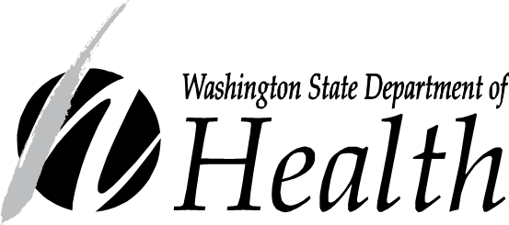
Retail Food Safety Advisory Council

Issue Submission Form
Food Code Section/Reference |  | Date Submitted |  |  | Issue Number:
 |  |  |  |  | Date Received:
Contact Information
Name

Agency or Organization (if applicable)

Phone |  |  | Email
Issues must be submitted at least 30 days before the next meeting in order to be considered.
Issue Information
Issue/Concern Description

Recommended Solution (if any)

Other Comments

Contact the Food Safety Advisory Council Coordinator at 360-236-3330 or food.safety@doh.wa.gov with questions.
Submit this form by:
Email  Open the online Word form and complete it, save the form to your computer, and then attach the form to an email addressed to:  food.safety@doh.wa.gov | FAX  360-236-2261 |  |  | Mail  Washington State Department of Health  Food Safety Program  PO Box 47824  Olympia, WA 98504

